Login to Grafna by using the user id and password access grafna with your public iP of main server or grafana installed servers by using port 3000

ex <https://publicip:3000>

Go into Dashboard and create new folder for storing our created dashboard

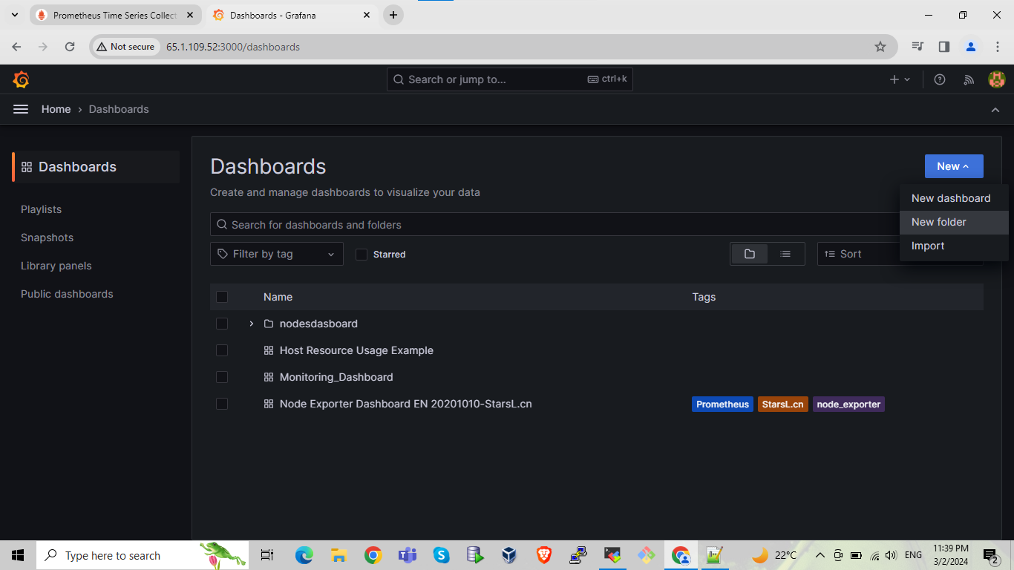

Here we are creating the folder with name Main_Hostin_Server by using same process crate folder for other servers for ex Production, testing, development give name to folder as per your choice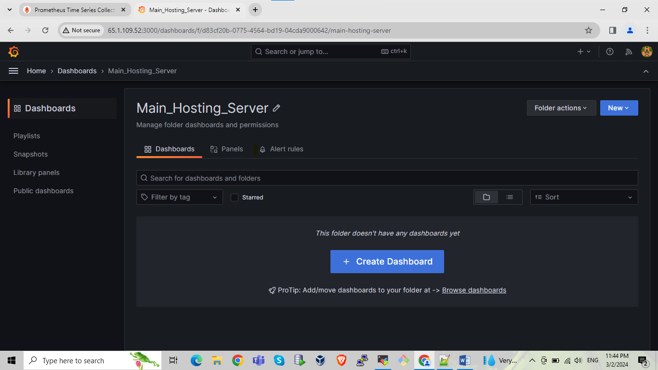

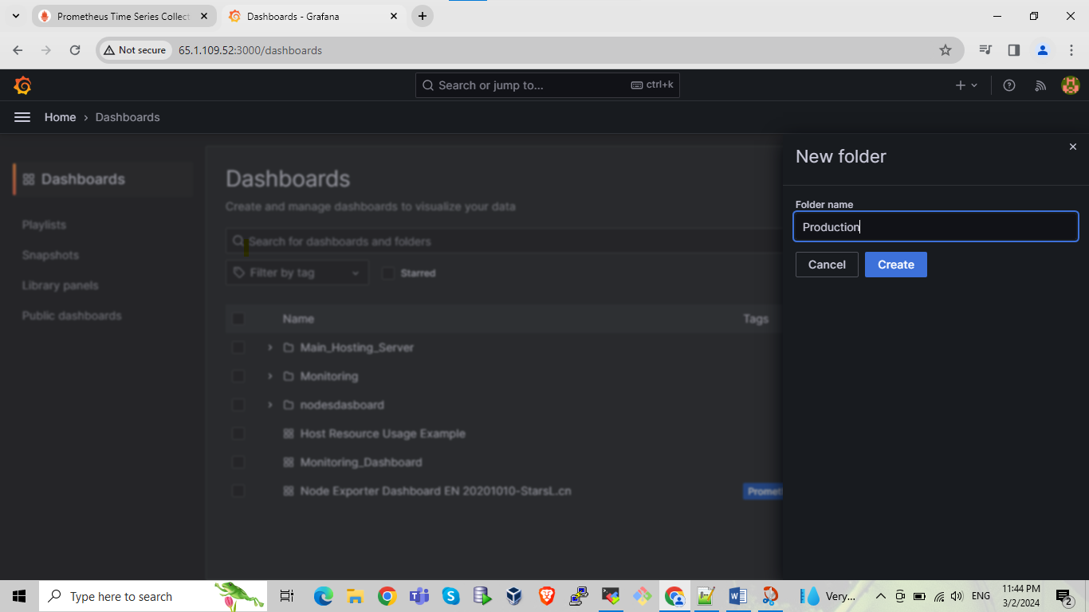

Here we can see the created folders are showing with their name main hosting server, production, development, testing

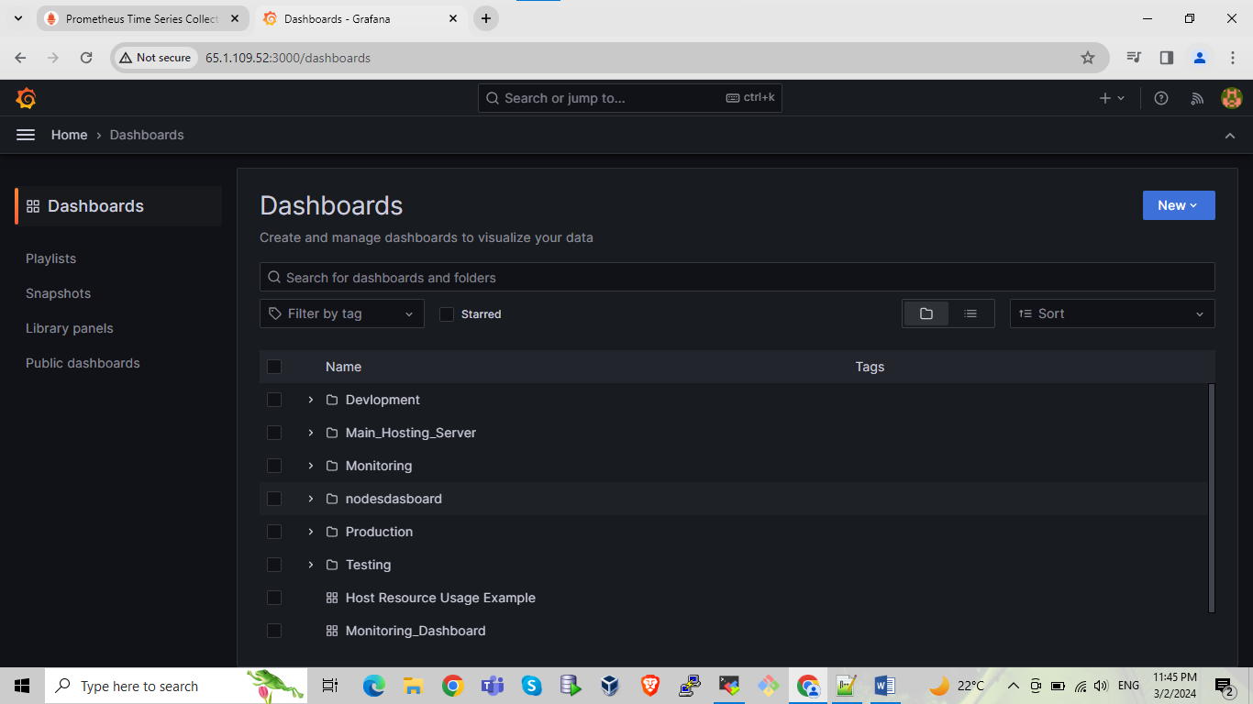

By selecting the one server we are creating the one ne dashboard for main server monitoring click on create dashboard then click on add visualization

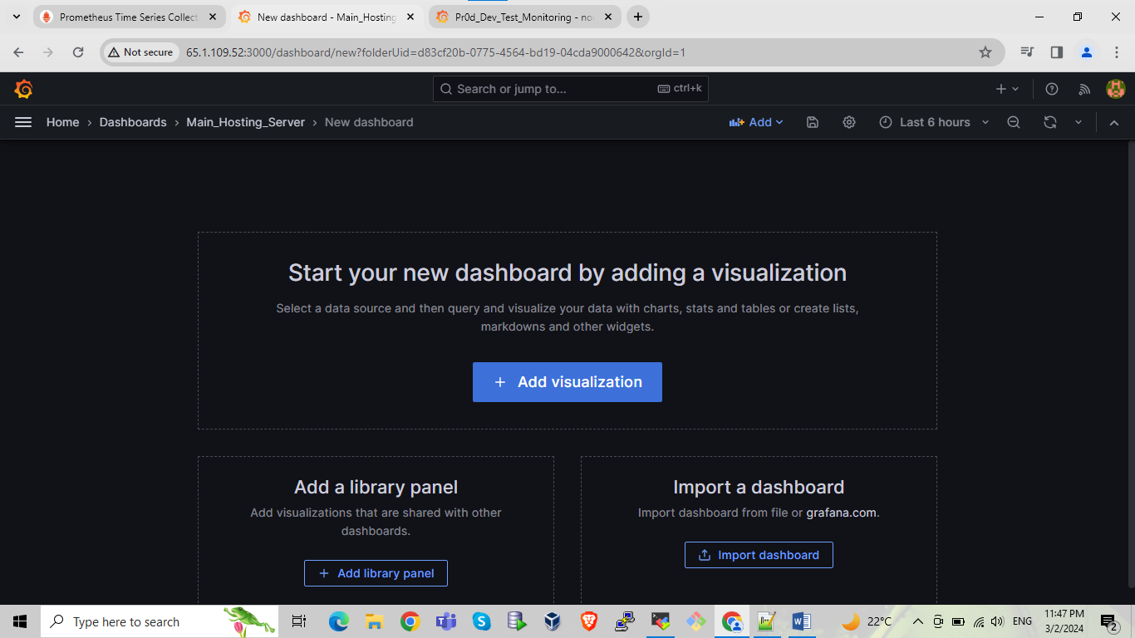

After that pop up showing for select one data source select data source as per your requirements.

here we are selecting the Prometheus default data source

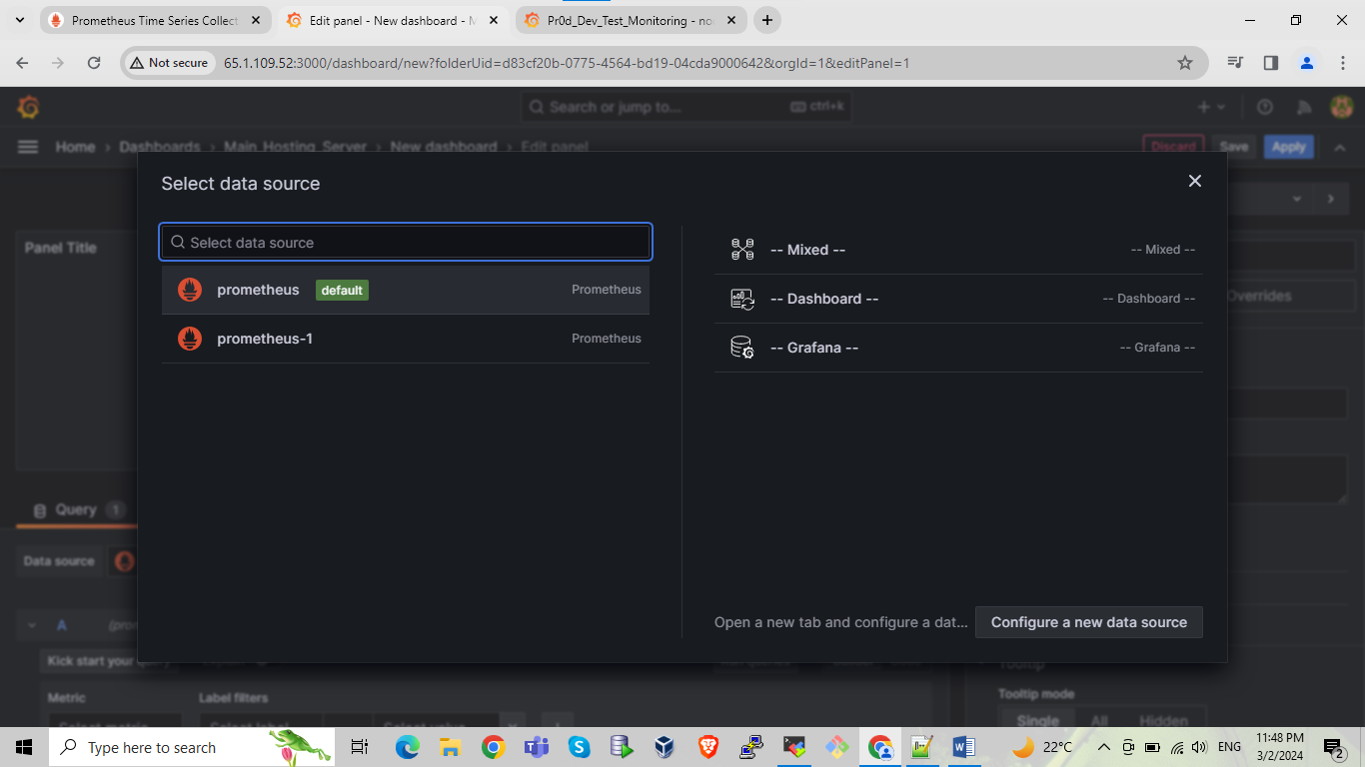

After selecting data source next panel will be open for creating the actual dash board here we can save apply dash board and doing the proper setting for the particular dash board as per our requirement

Here we can see we put one PmQl query in query section box if query box not showing for writing query then select the code option which is next to build after that click on run quires it will showing the o/p or error if any error resolve it and run query again

cpu utilization query

avg without(cpu) (irate(node_cpu_seconds_total{job="remote_collector",instance="localhost:9100", mode!="idle"}[1m]))

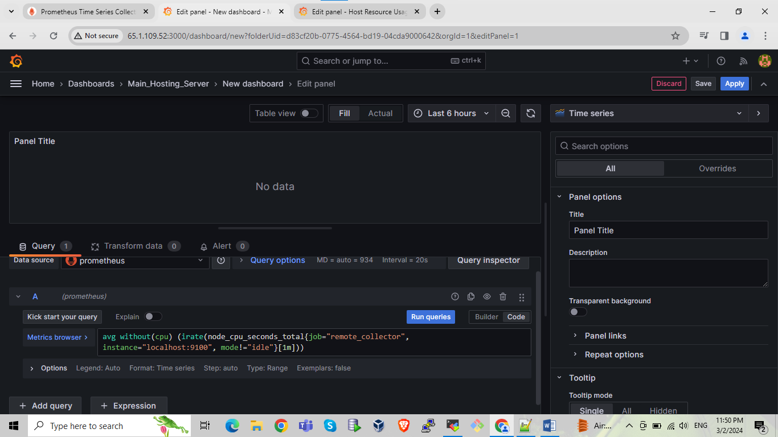

Here we are run the queries its showing the successfully one o/p we are creating the dashboard/panel for cpu utilization we are giving the title name into to right side of panel options

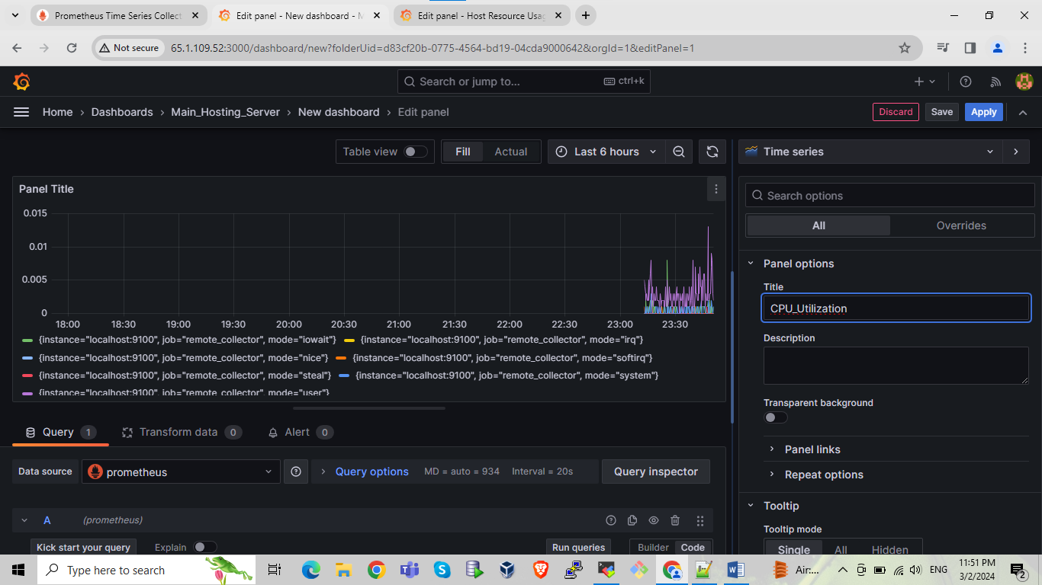

In below ss we are making setting for unit and we are selecting unit for percentage before that we can see in graph left side of panel y axis not showing the percentage unit

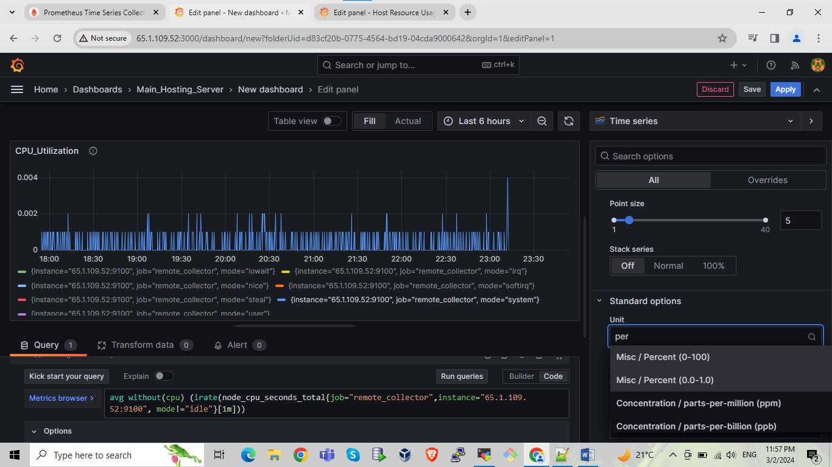

After selecting UNIT we can see values of y axis is showing in the percentage

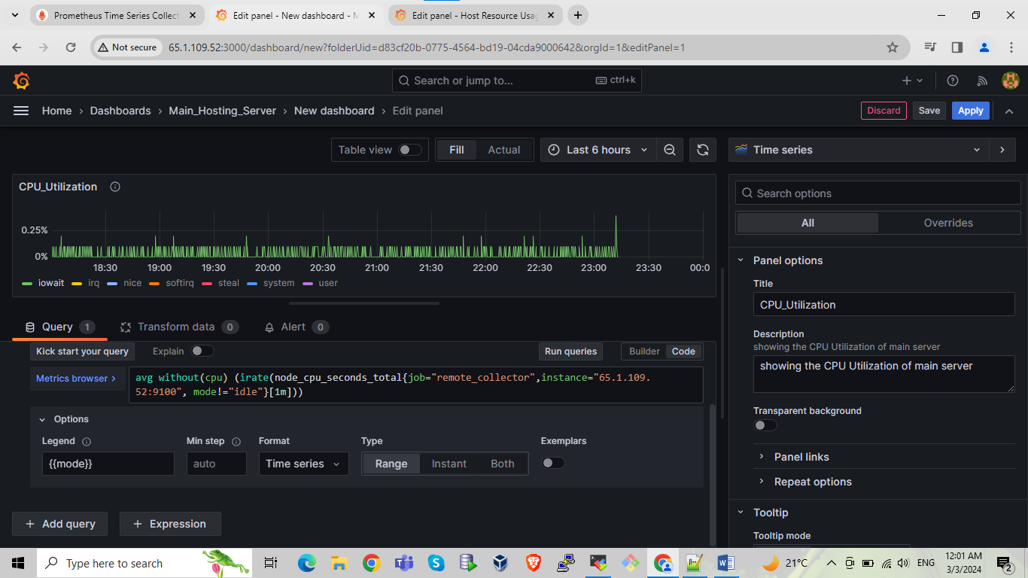

In below ss we can see that we are giving the label name for y axis its percentage after done all setting click on save and give name to panel and then click on apply it will showing the finale panel

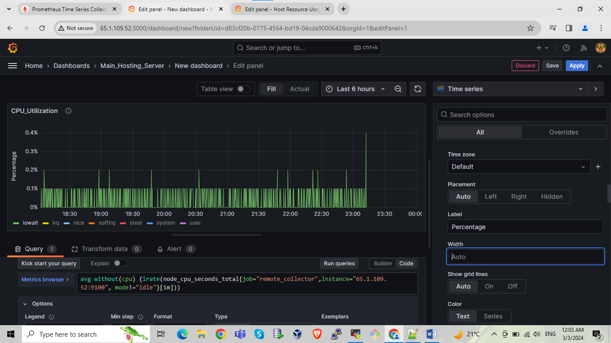

After creating one panel we are creating next panel for that select add option select visualization

Do same steps as we have done previously write query🡪run queries 🡪title name🡪unit🡪save🡪name to panel🡪apply

Here we are creating panel for Memory Usage

Here we are using the 3 queries for memory usage, cached memory, and free memory

The below are the provided queries put first query in first section test it if ok then click on add query and put second query and test it dome same for third one also

----------------------------------

memory usage

section A query:-

node_memory_MemTotal_bytes{instance="localhost:9100",job="remote_collector"} - node_memory_MemFree_bytes{instance="localhost:9100",job="remote_collector"} - node_memory_Cached_bytes{job="remote_collector",instance="localhost:9100"} - node_memory_Buffers_bytes{instance="localhost:9100",job="remote_collector"}

section B query:- node_memory_Buffers_bytes{instance="localhost:9100",job="remote_collector"}

section c query:- node_memory_Cached_bytes{instance="localhost:9100",job="remote_collector"}

section D query:-node_memory_MemFree_bytes{instance="localhost:9100",job="remote_collector"}

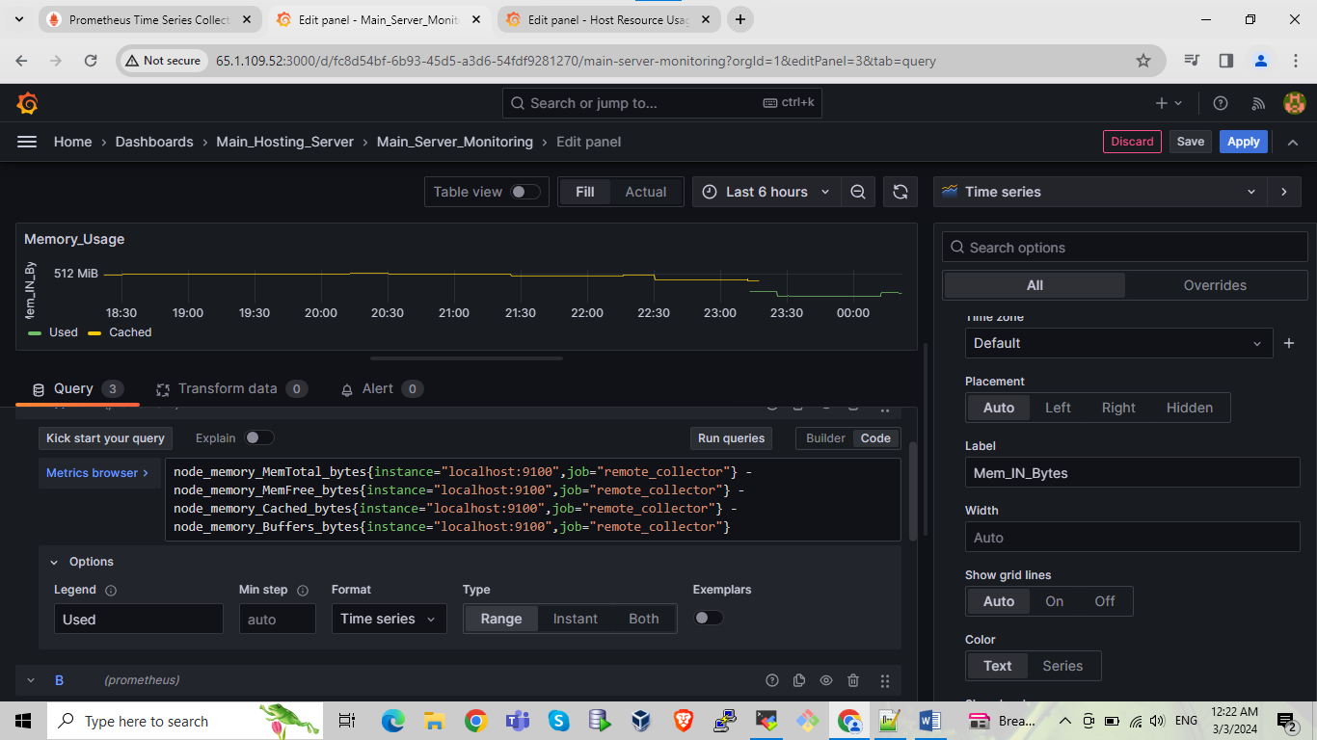

In memory usage panel add next query for that we can see the option add query click on it and add query run it and test it

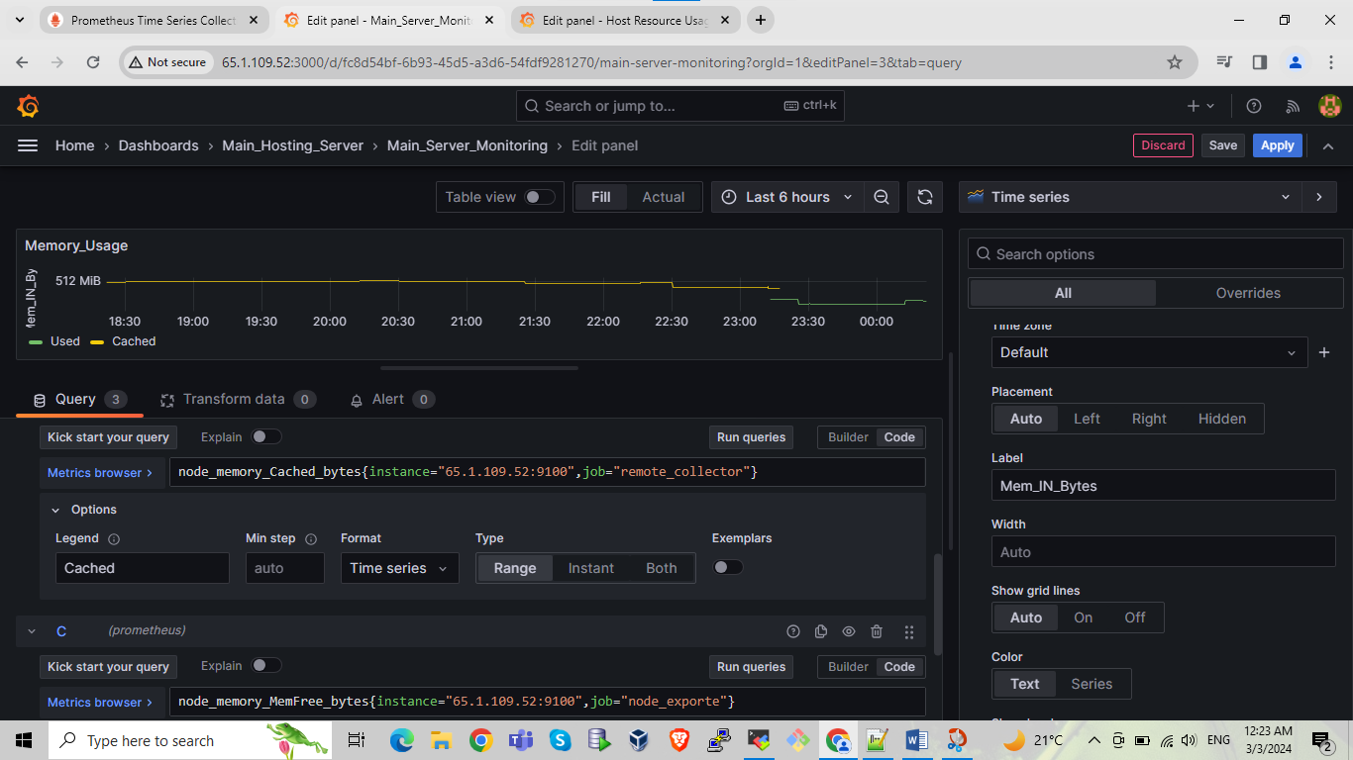

In memory usage panel add next query for that we can see the option add query click on it and add query run it and test it

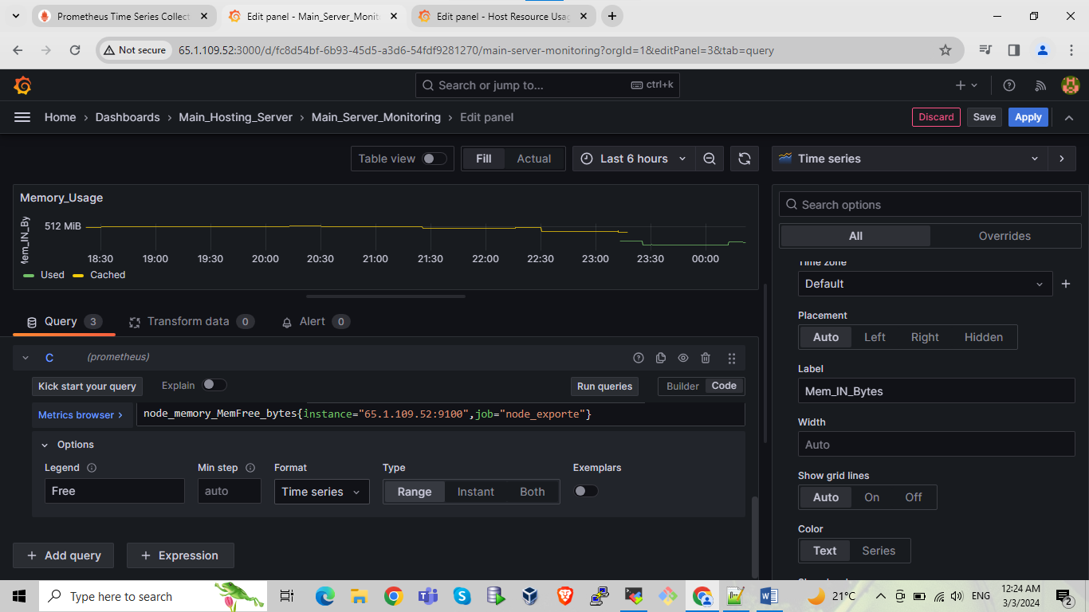

Do some settings as per ss

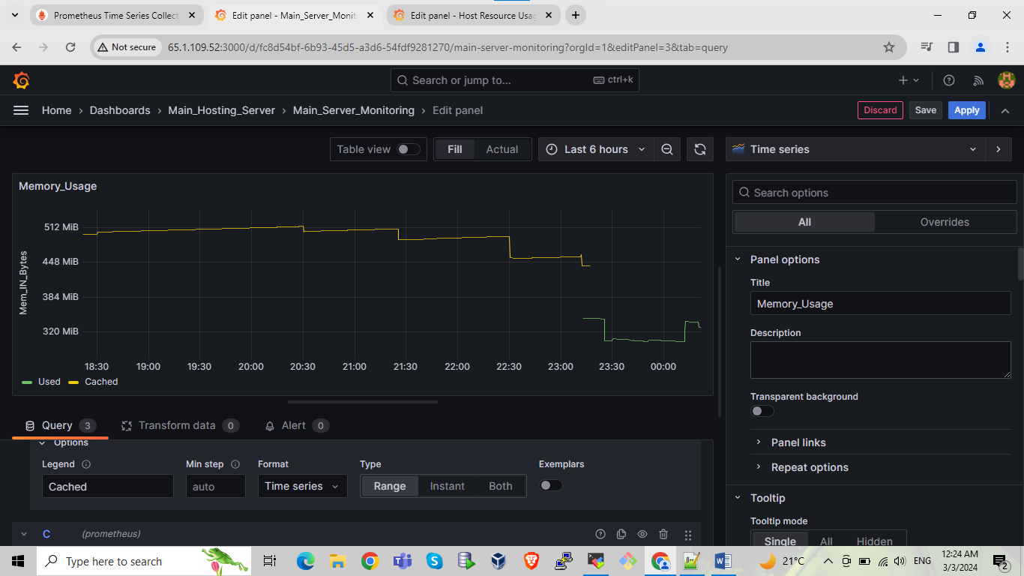

Do some settings as per ss

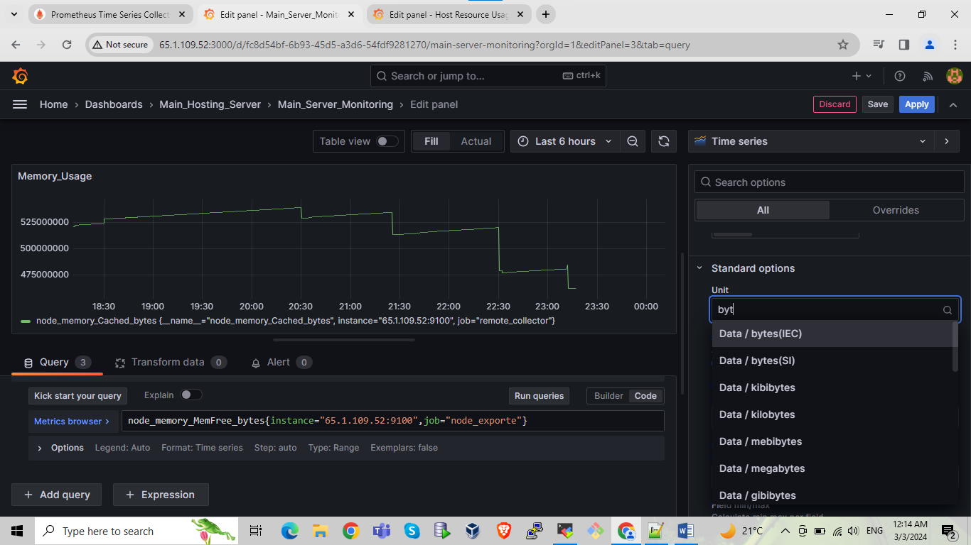

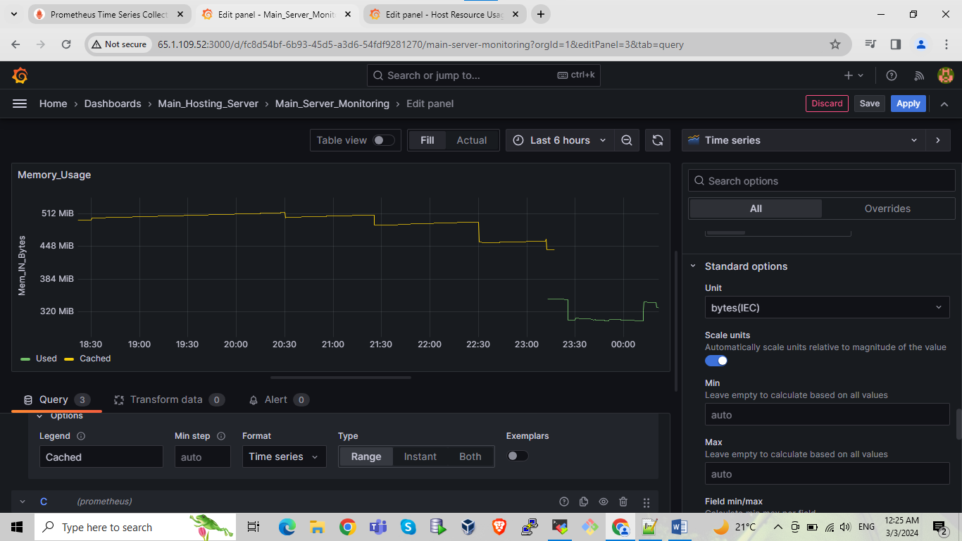

Do some settings as per ss

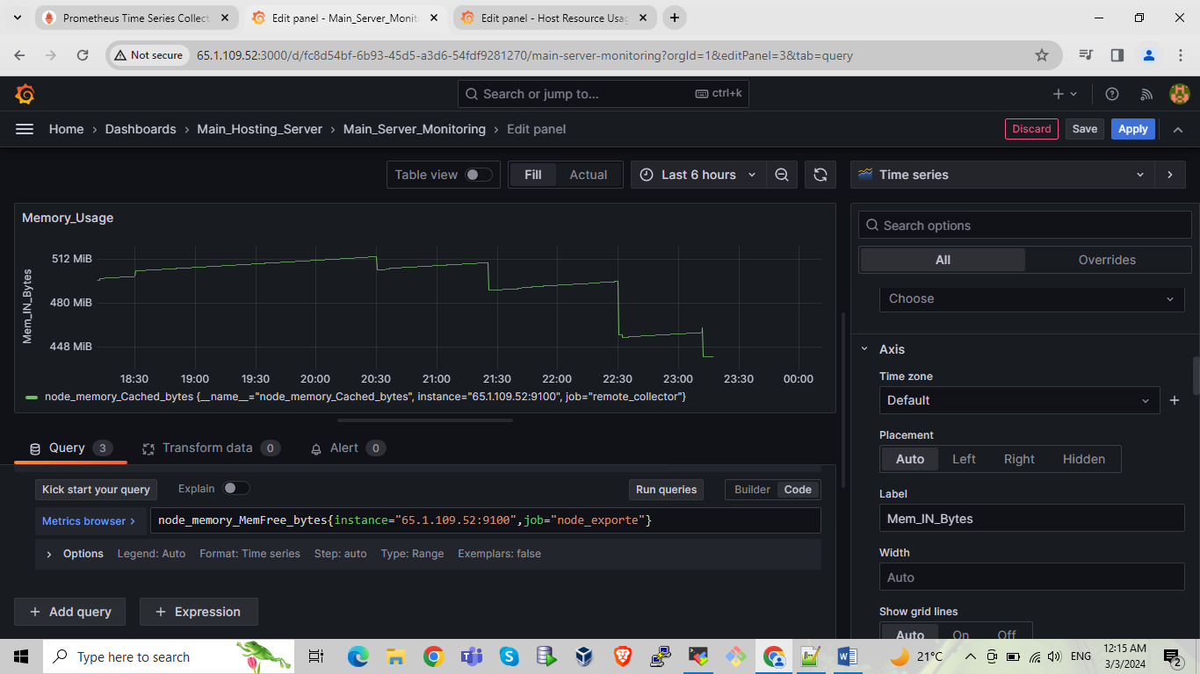

After creating one panel we are creating next panel for that select add option select visualization

Do same steps as we have done previously write query🡪run queries 🡪title name🡪unit🡪save🡪name to panel🡪apply

Here we are created panel for Network/traffic management

n/w traffic

section A query:-

irate(node_network_receive_bytes_total{job="remote_collector",instance="localhost:9100"}[5m])

-------------------------------------------------------------------------------------------------------------------------------------

section B query

irate(node_network_transmit_bytes_total{job="remote_collector",instance="localhost:9100"}[5m])

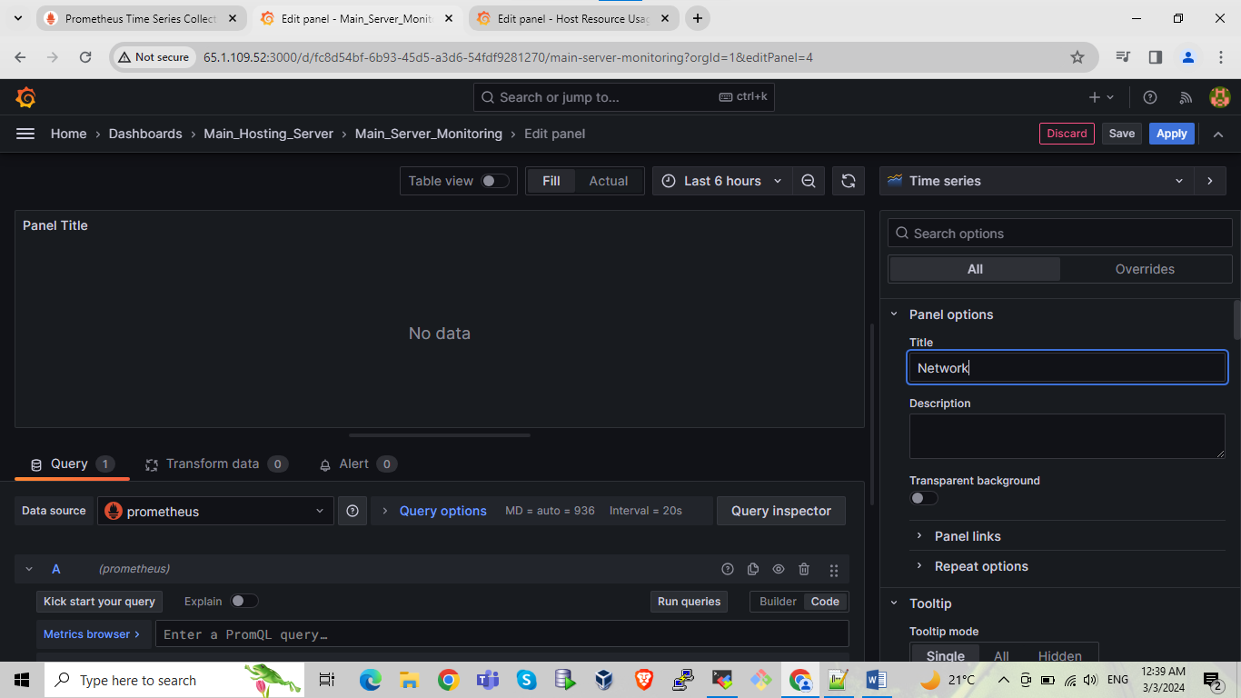

Do settings as per below SS

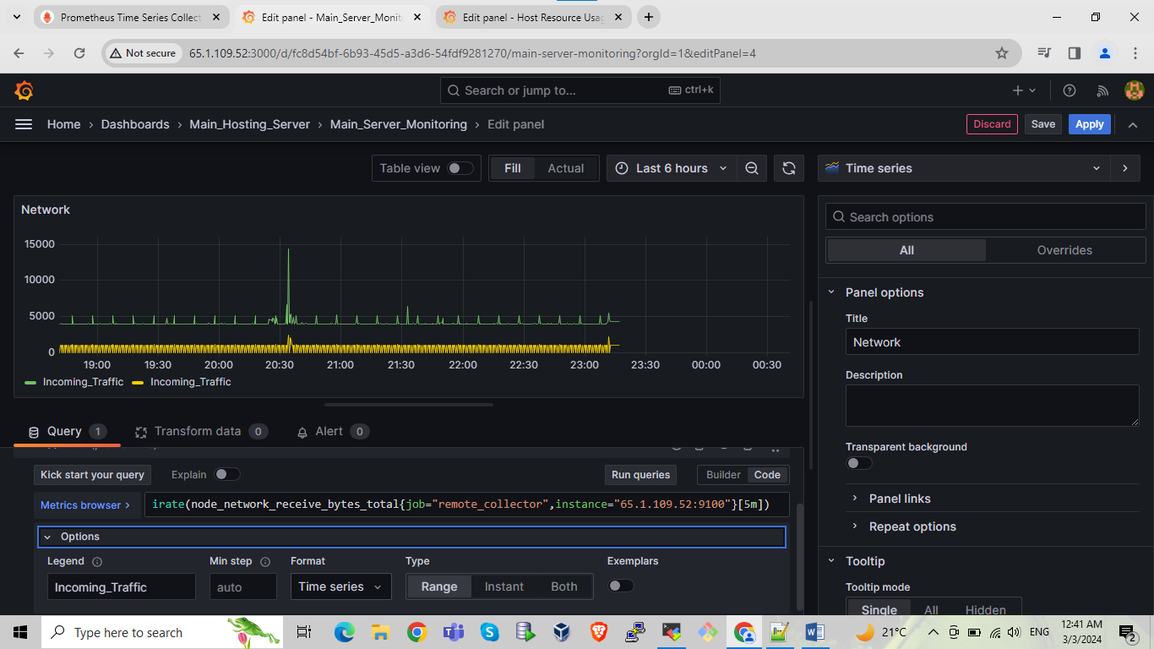

Do settings as per below SS

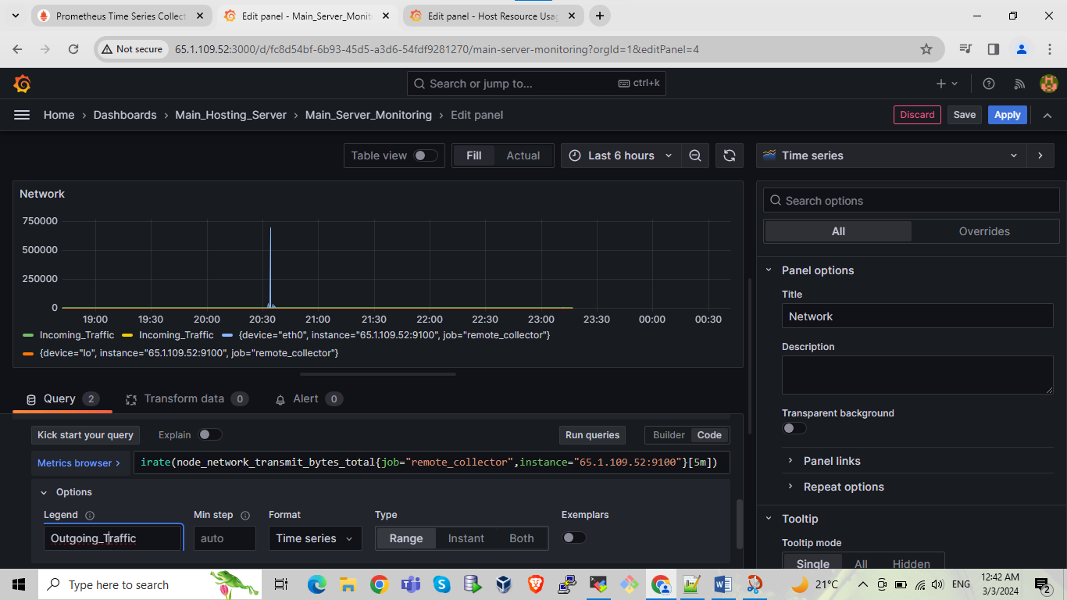

Do settings as per below SS

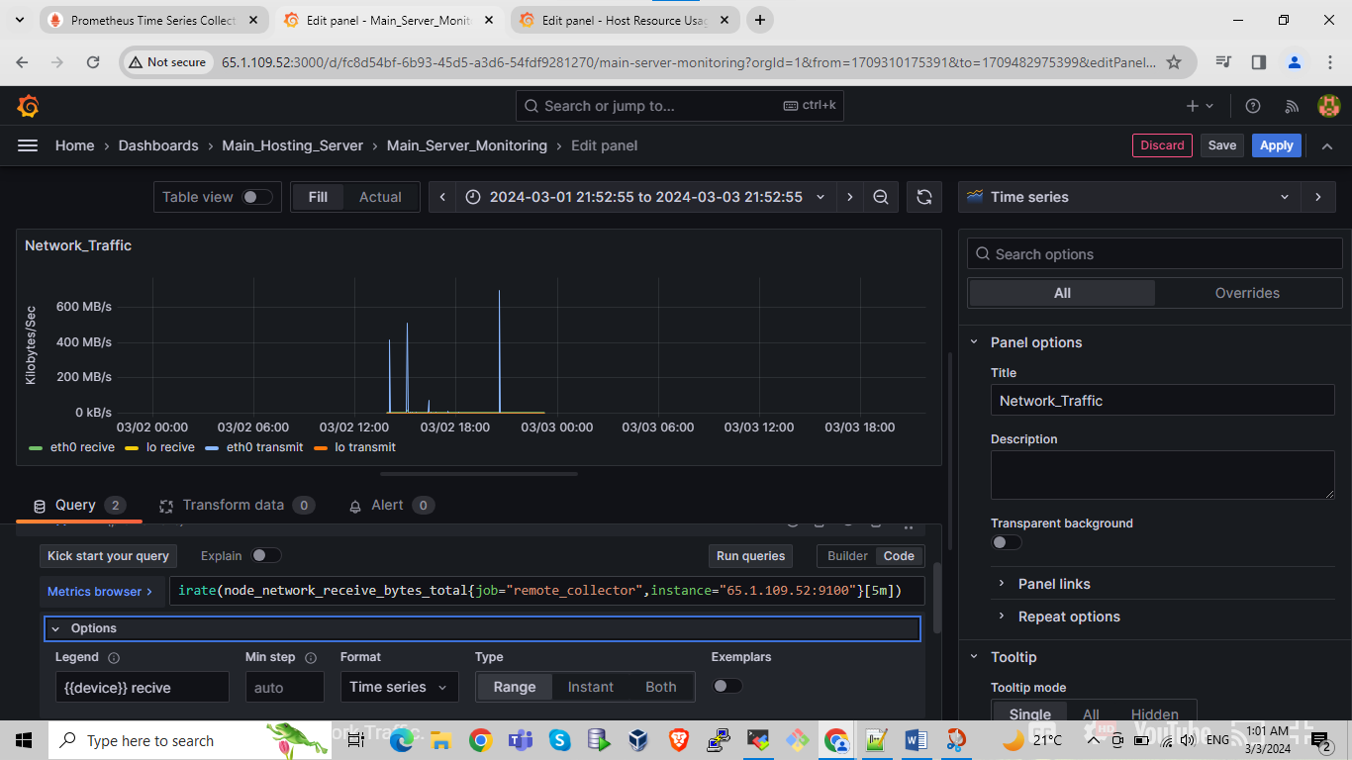

Do settings as per below SS

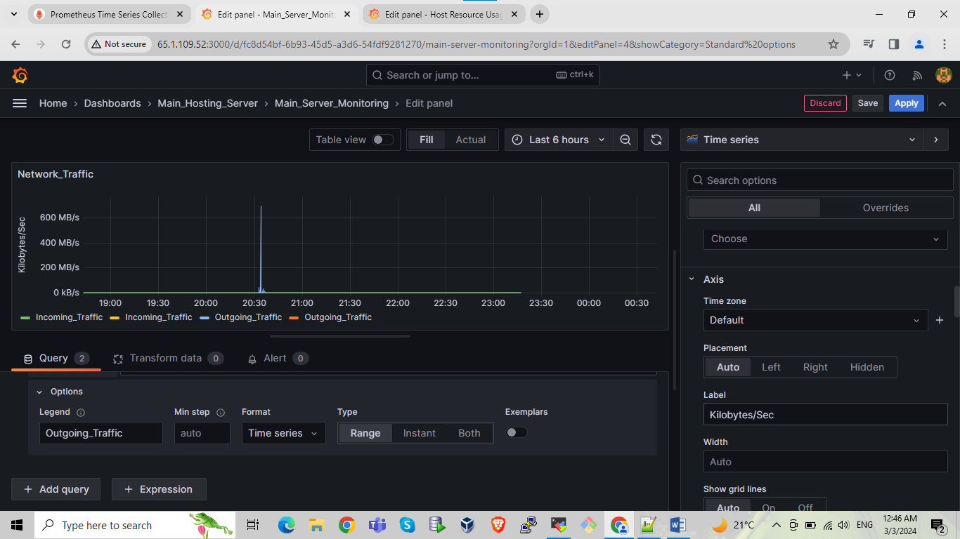

Do settings as per below SS

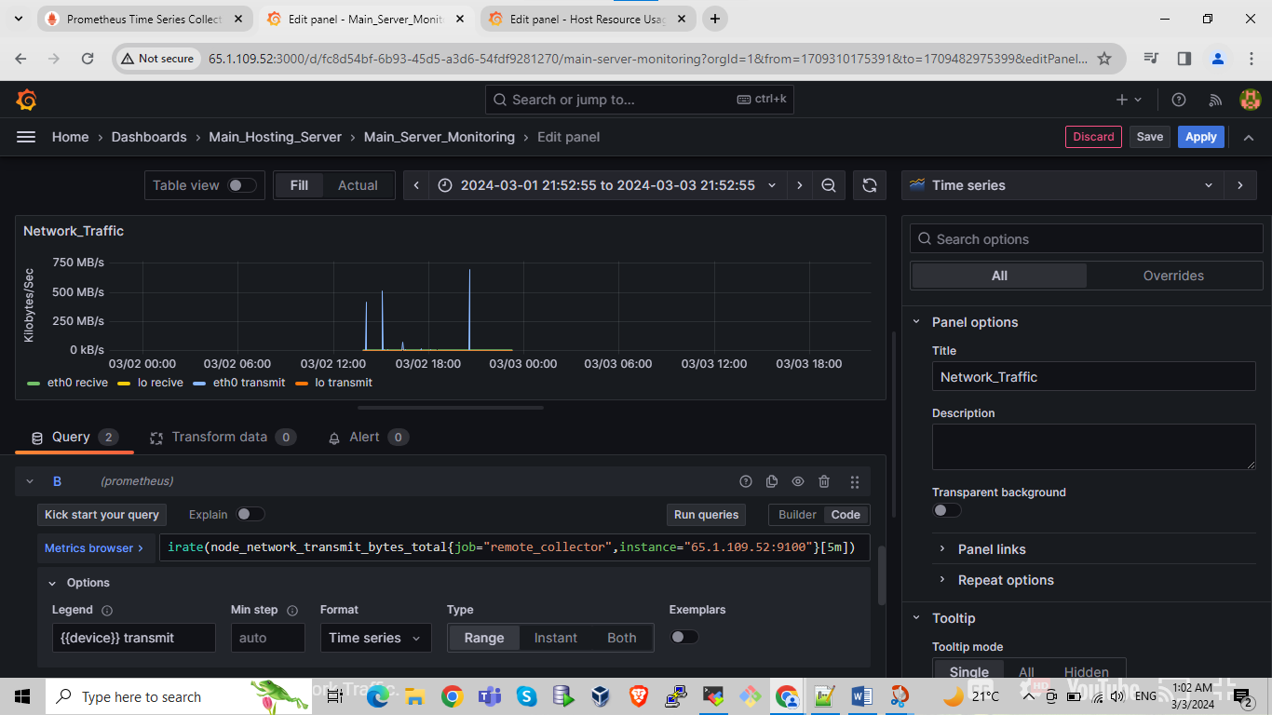

After creating one panel we are creating next panel for that select add option select visualization

Do same steps as we have done previously write query🡪run queries 🡪title name🡪unit🡪save🡪name to panel🡪apply

Here we are created panel for used memory

used

node_filesystem_size_bytes{job="remote_collector",instance="localhost:9100",device!~"/dev/loop.*", device!~"tmpfs|nsfs", device!="gvfsd-fuse"} - node_filesystem_avail_bytes{job="remote_collector",instance="localhost:9100"}

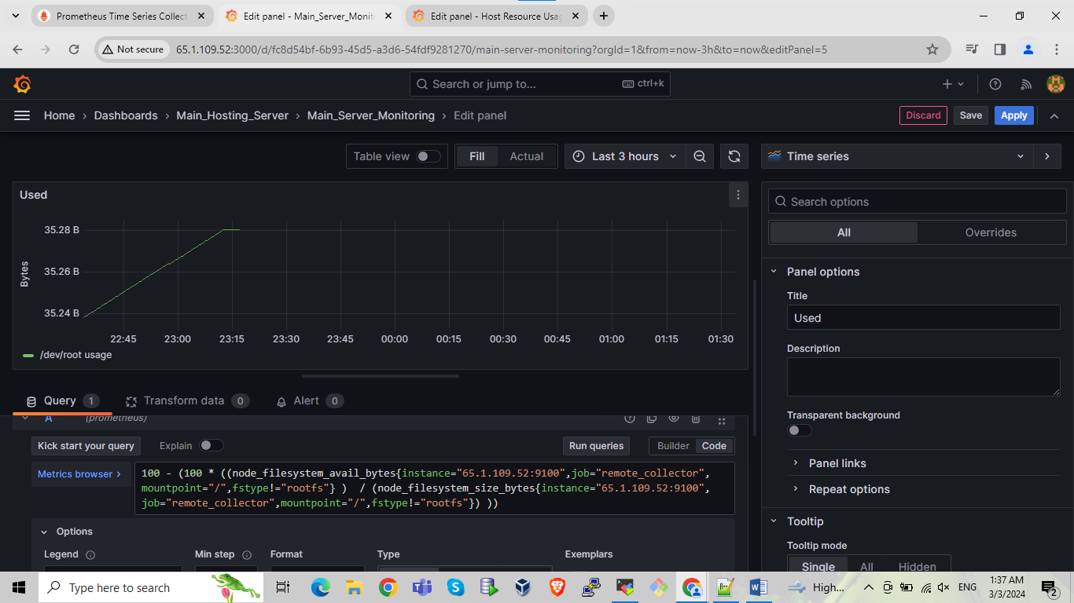

Do settings as per below SS

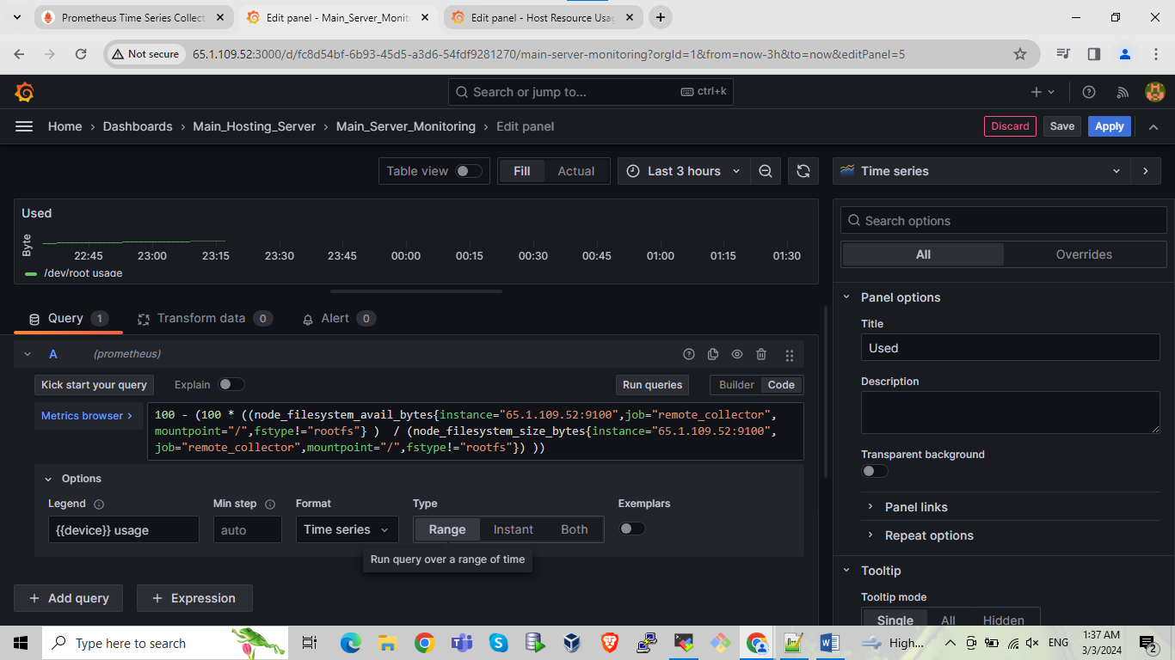

Do settings as per below SS

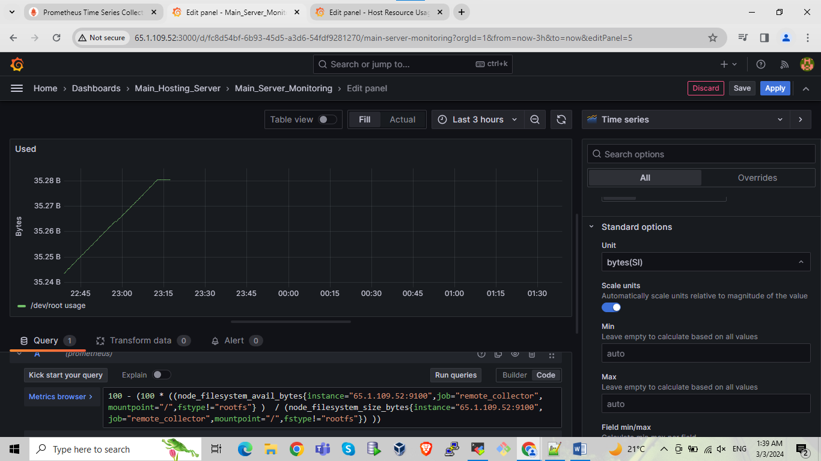

**------------------ALERT Configuration on Grafana------------------**

Go in Alerting tab select alert rules click on new alert rule

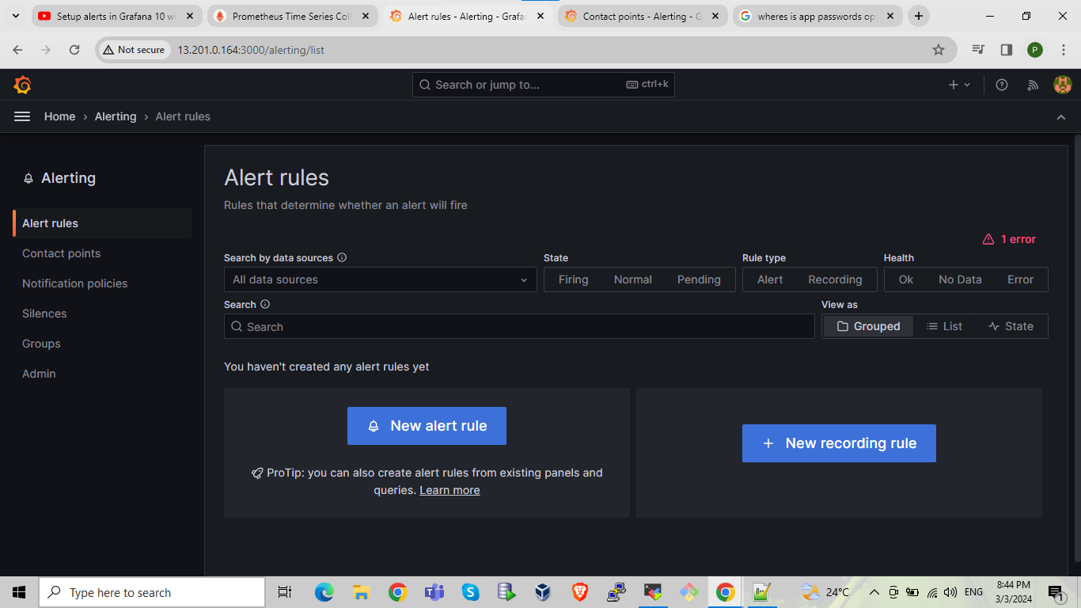

Do some settings as showing in below SS add query in query section for checking the alerts

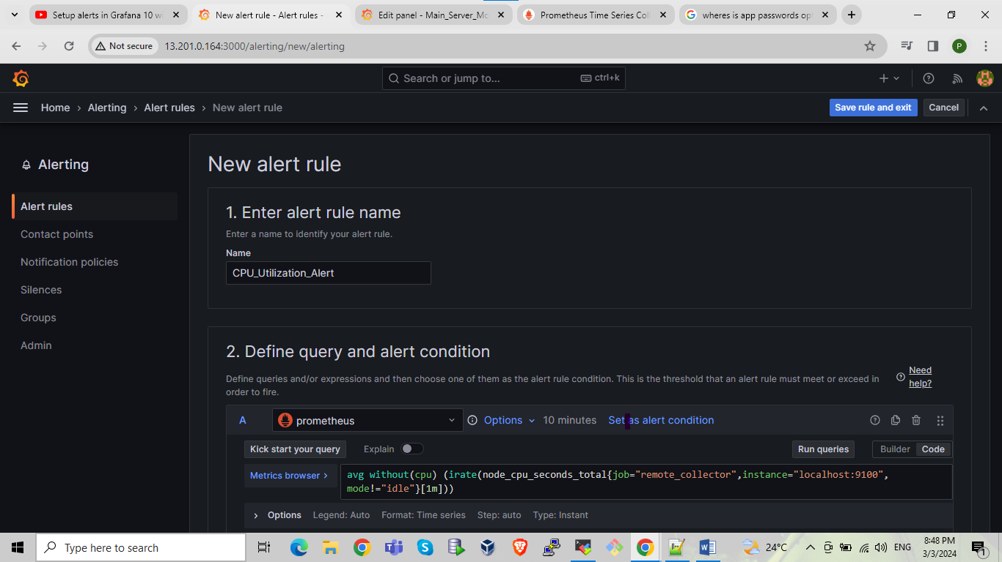

Do some settings as showing in below SS add in option section we can set alert for particular time period or live as it is for checking all time.

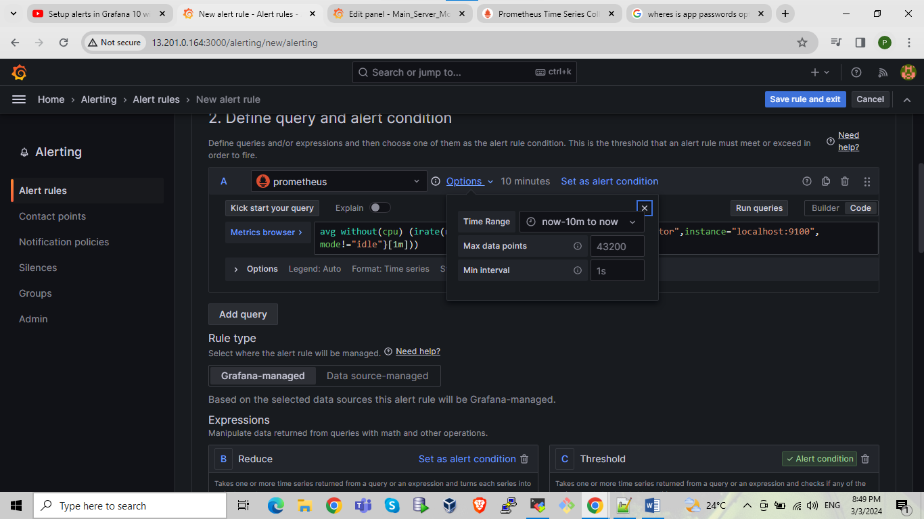

Setting for alert if required in set alert condition section for particular range

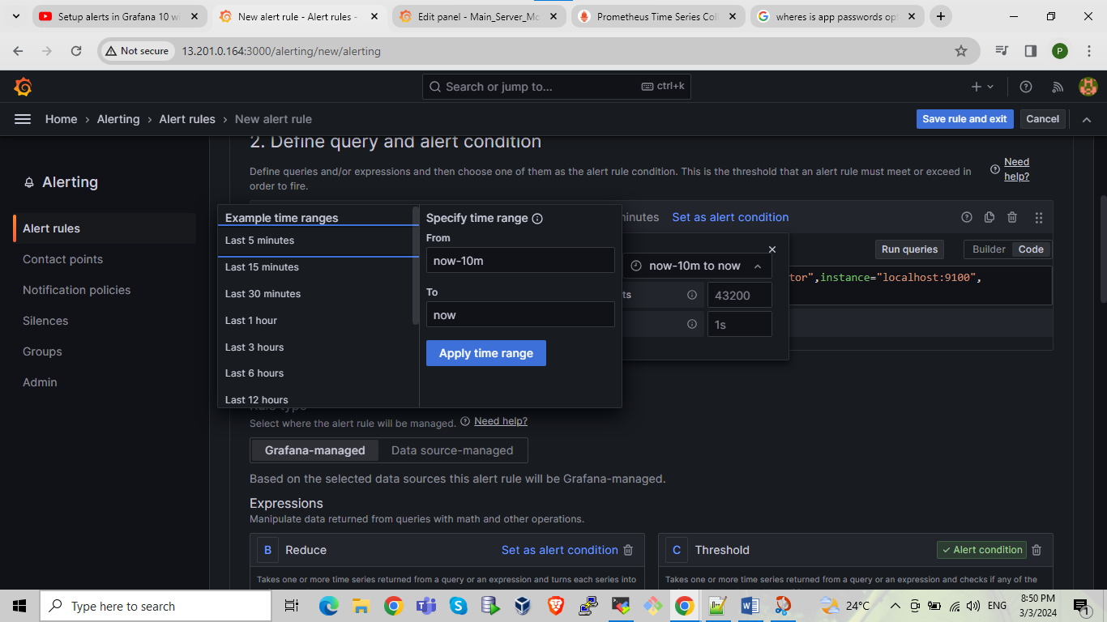

After running queries it will show the o/p

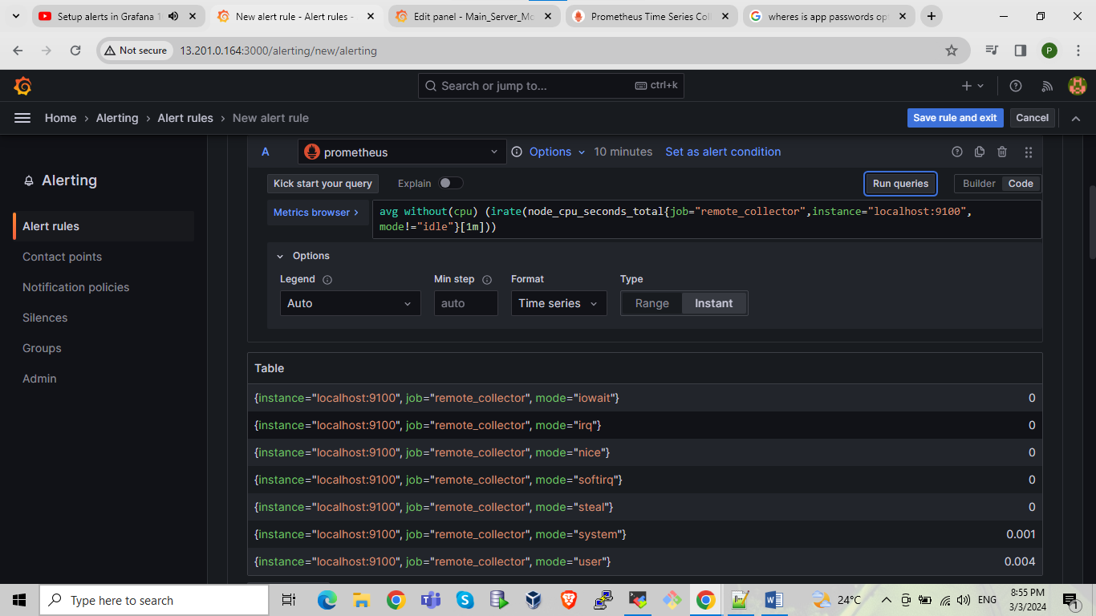

Here we can set condition in reduce section we taking here function is last mode is strict measn check the last state of CPU utilization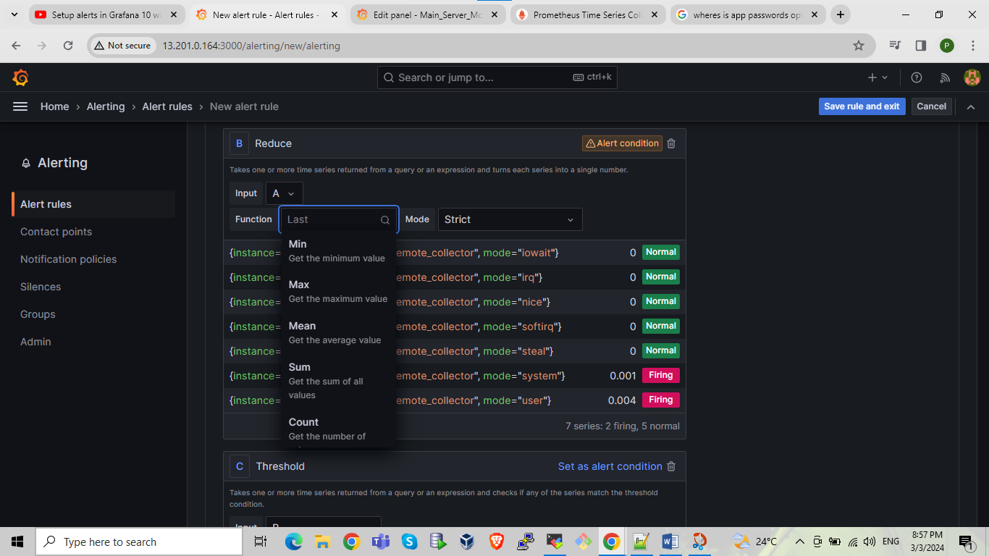

In threshold section we are doing setting as per our requirement. Is above means here we are selecting 60 or 0.6 means when cpu utilization going beyond 60% it will send alert the cpu utilization is high.

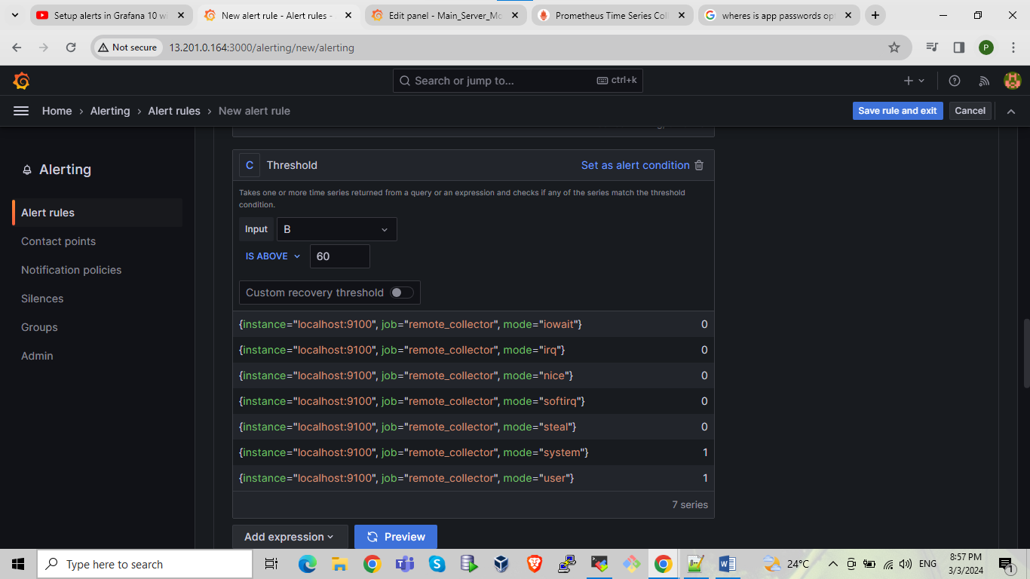

Or we can create classic conditions so we can create classic conditions or reduce threshold conditions refer SS

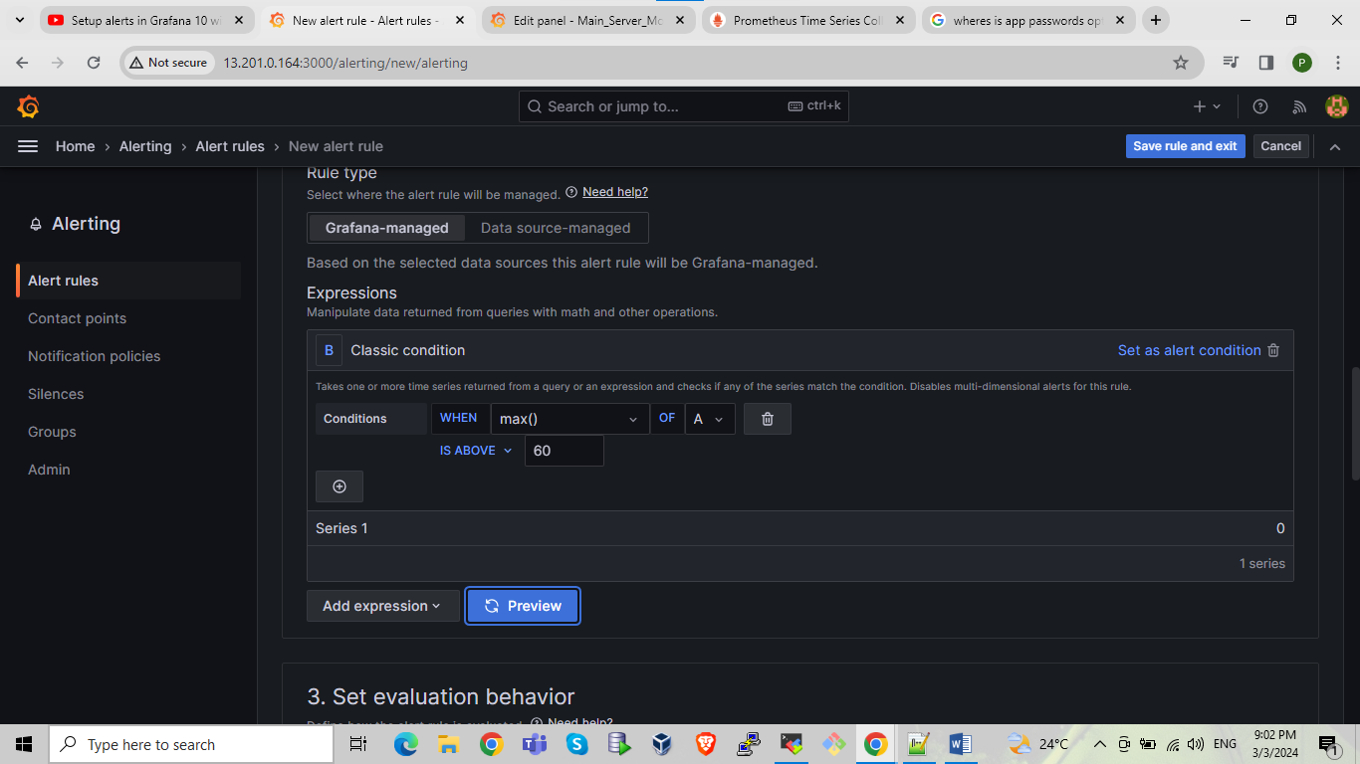

In set evaluation behavior section create the new folder or selecting the already available folder we can manage pending period means its giving the alert in that particular time

Here we are setting pending period is 0 (zero) means when alert is generating immediately sending the alert as we can say above fit we live as it for 5m then it will wait for 5 min if alert is not resolve then send it if resolve in 5m then not sending the alert

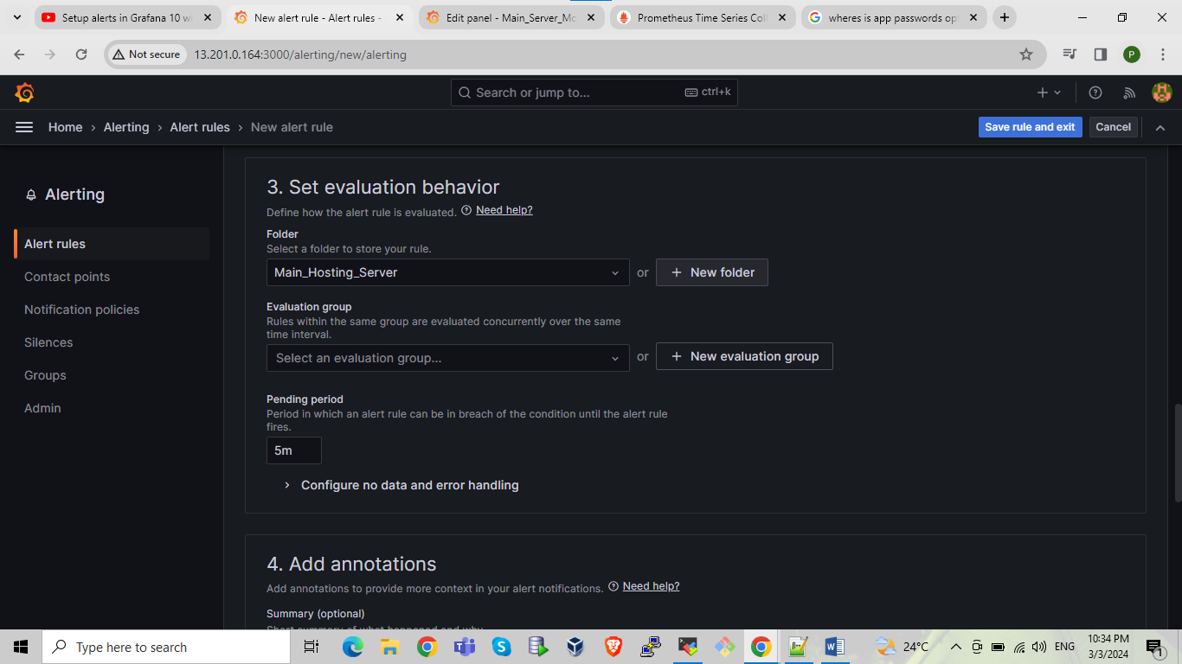

Click on new evaluation group give name to group and set evaluation level as per your choice if we set 1m then it will run in 1 min if we select 10 sec then it will run every 10 sec

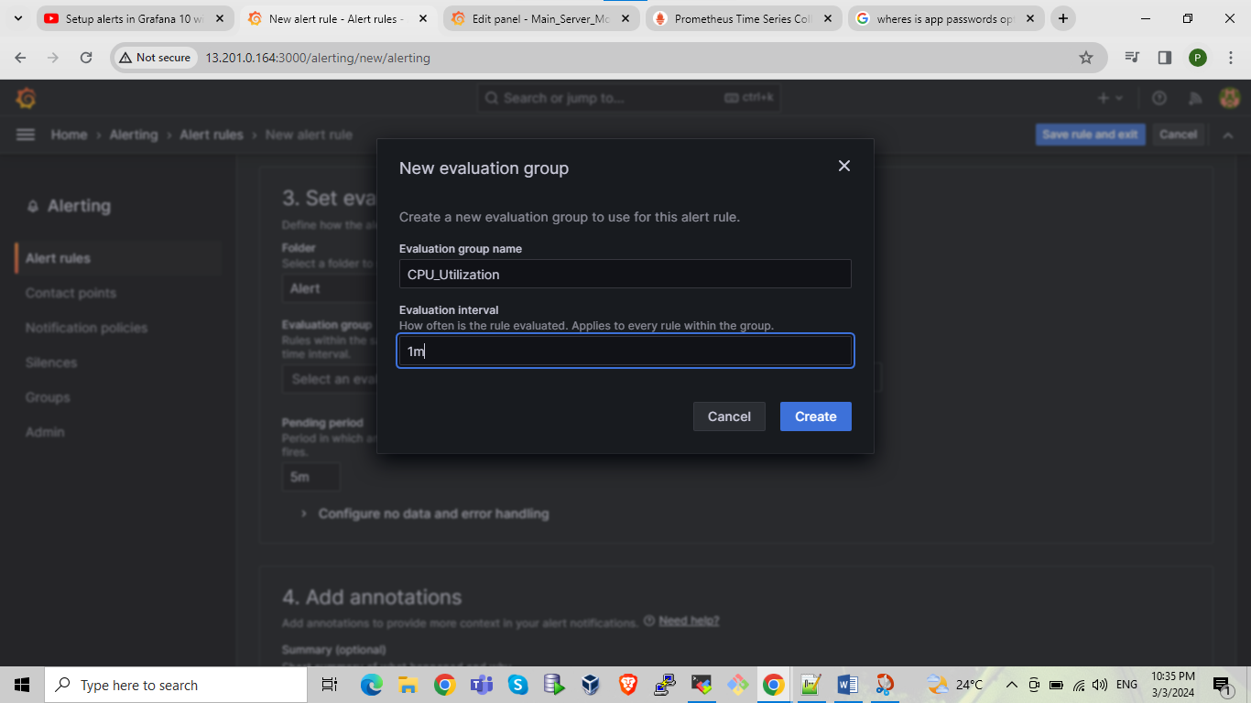

We are giving label as per requirement in label section here we are giving team name give it’s in key value format

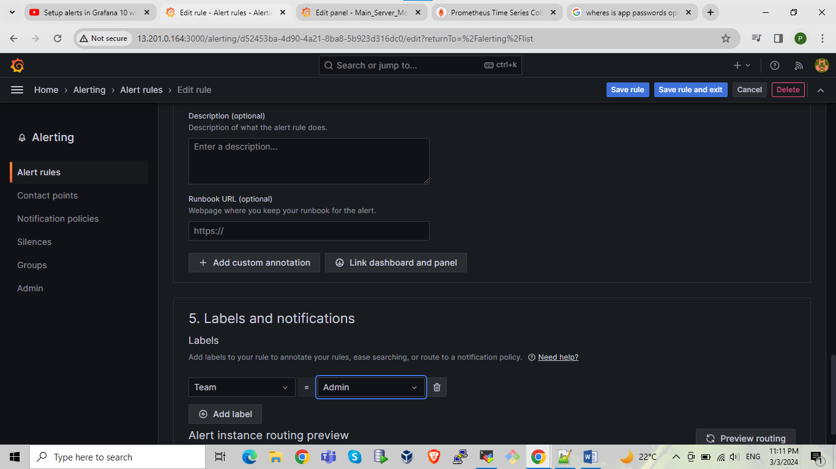

After that click on save and exit the alert rule is successfully created refer the below SS

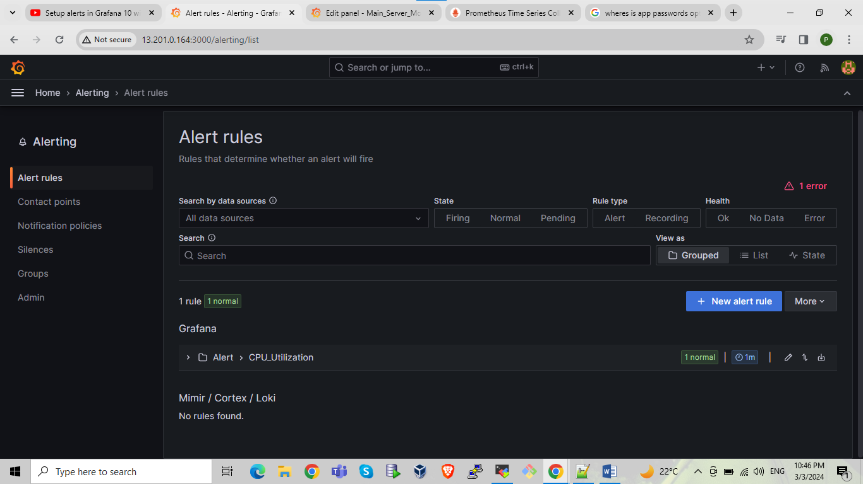

Next click on contact points and do setting for contact points we can create multiple contact points

Here we are giving the name admin team mail because at time of alert creation in label section we are giving the label is team admin integration is email add email address or team mail address

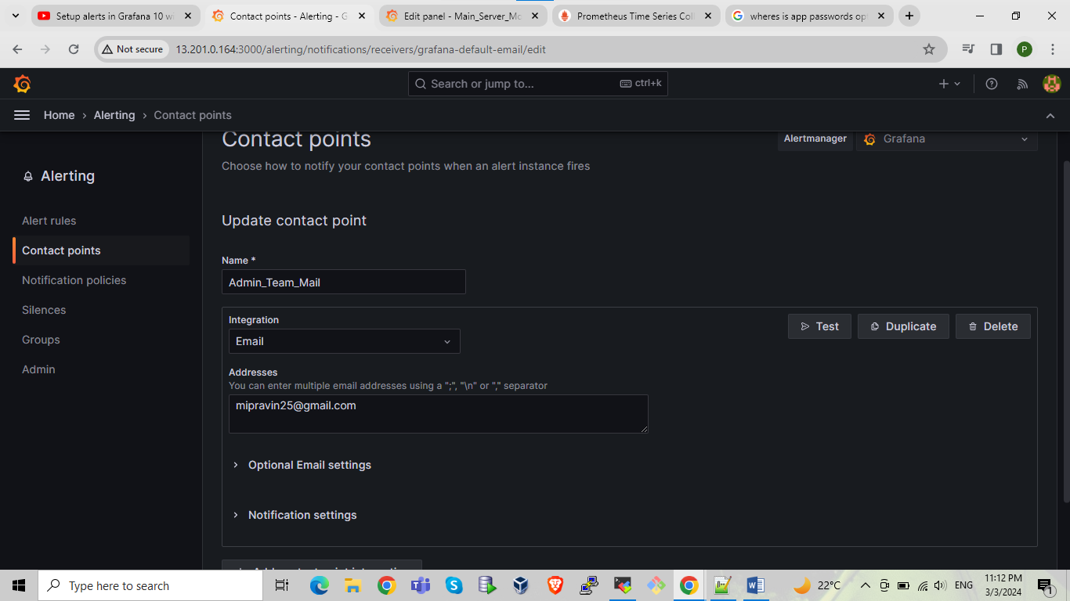

Click on test it showing the SMTP error

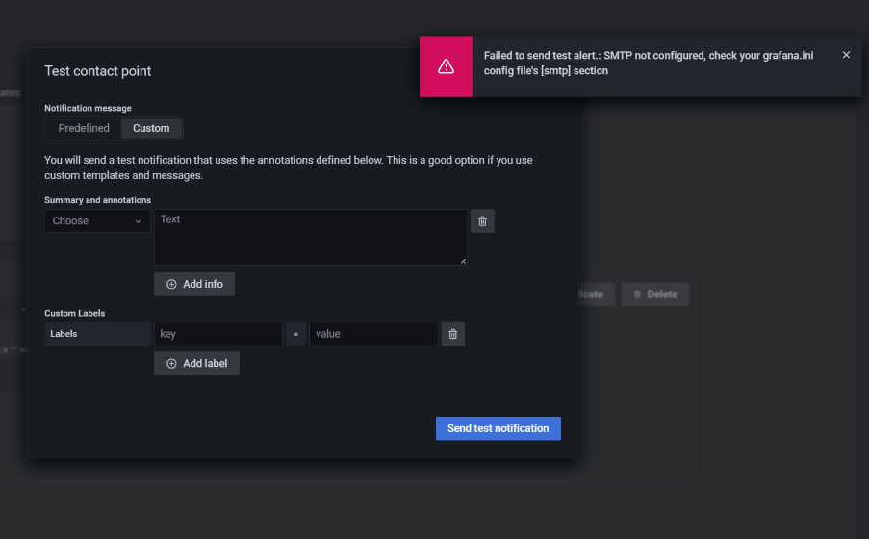

For resolving error do the following steps

first we want to do setting for email in garfana.ini so go into main hosting server and go in to below path and do setting for SMTP

Command :- cd /etc/grafana/grafana.ini or sudo vim /etc/grafana/grafana.ini

After doing the below changes in grafan.ini for SMPT then restart the grafana with below command

Command:- systemctl restart grafana.service

Command for Check status systemctl status grafana

Scroll down and do changes in SMTP section like below means uncomment the as per showing in below if its commented if not available then write.

--------------------------------------------------------------------------------------------------------------------------------------------

[smtp]

enabled = true----------------------set true if its false

host = smtp.gmail.com:587 --------------uncomment here

user = mipravin25@gmail.com --------give user name as email id

password = fhtbvslopenbgetl ----------create password in Gmail account

##(for the creation above password refer the below section of creating password for SMPT connection)

skip_verify = true ---- uncomment and if its false then set it to true

from_address = mipravin25@gmail.com ----- write here email id

from_name = Grafana ---uncomment or if not present then write

--------------------------------------------------------------------------------------------------------------------------------------------

section of creating password for SMPT connection

login to email account go into account section



Select security section and select 2 step verification

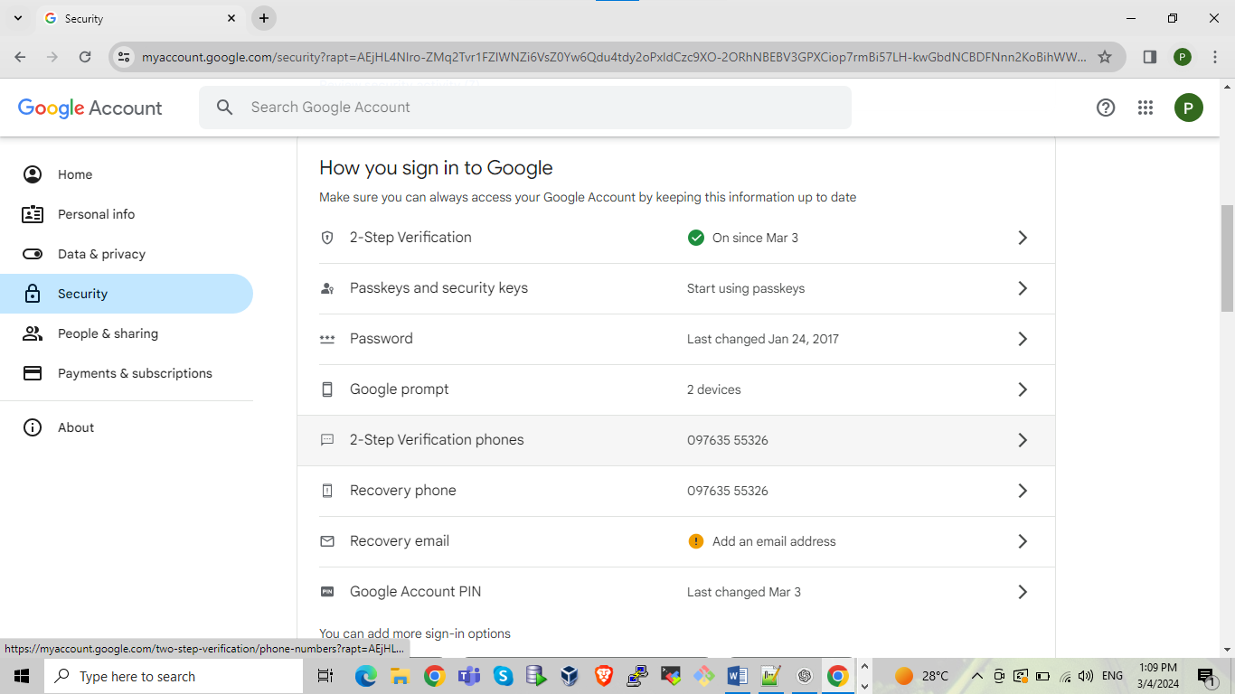

Select app password

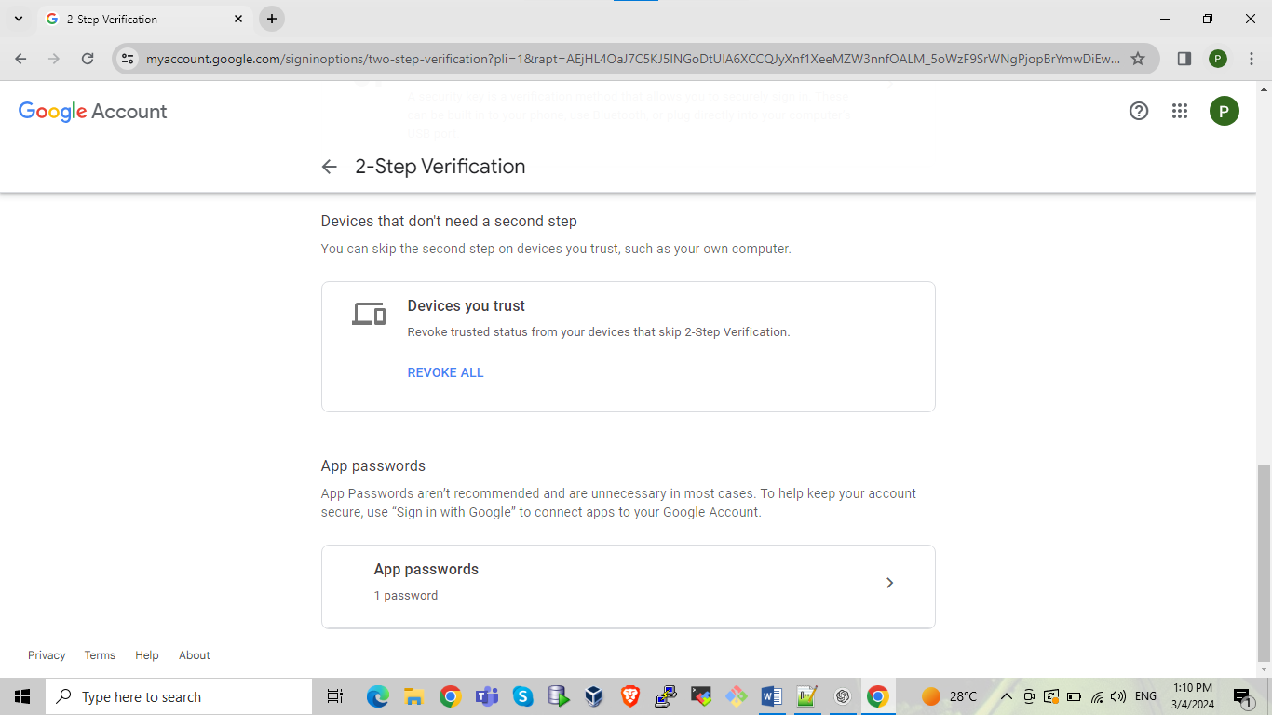

Give app name and click on create

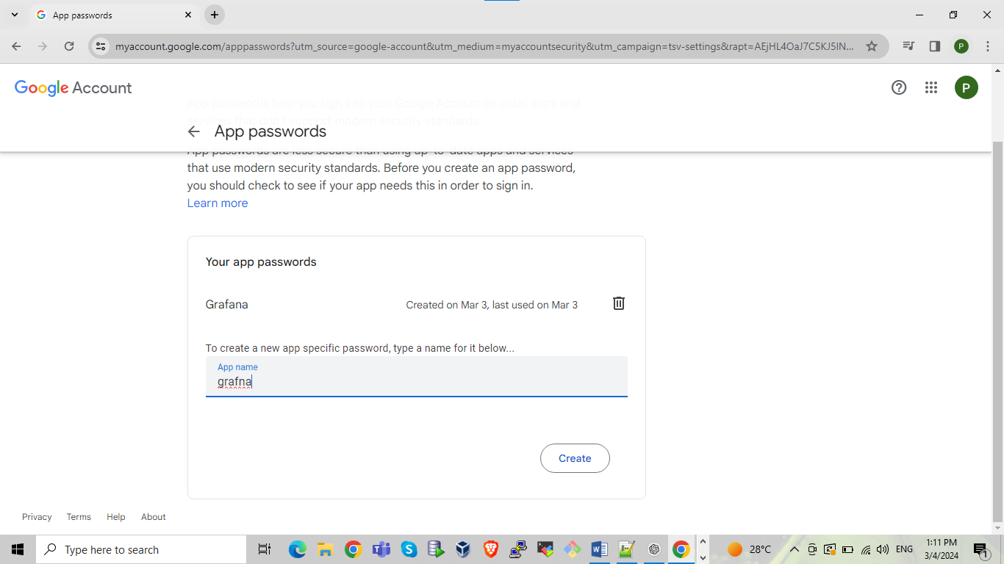

Password will created and showing generated password copy that password and paste it into grafna.ini file

In SMTP section where the password filed is available

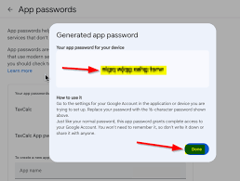

After setting done in grafna.iniGo into grafana dashboard select contact points



Click on test now it will showing sent successfully messages refer below SS

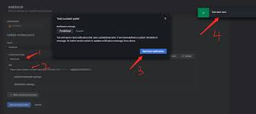

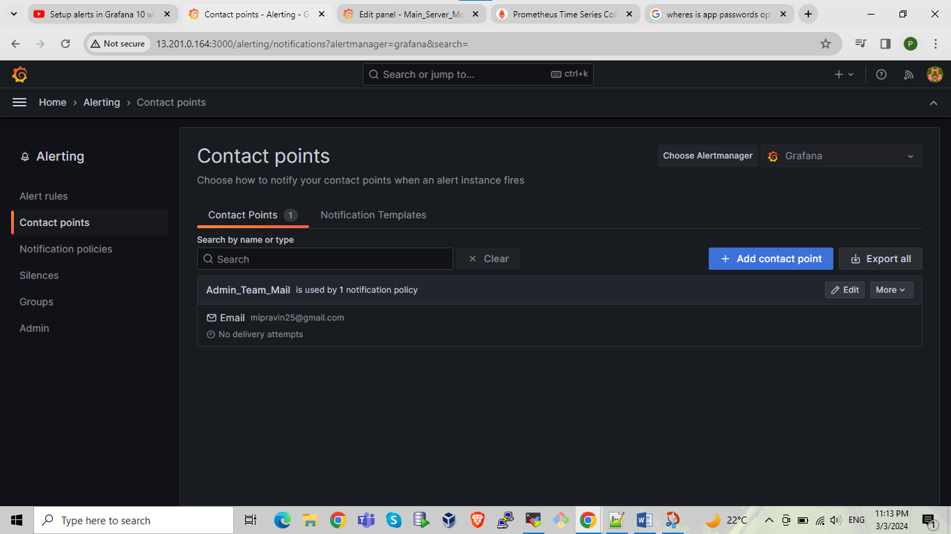

Now select notifications policies select new nested policy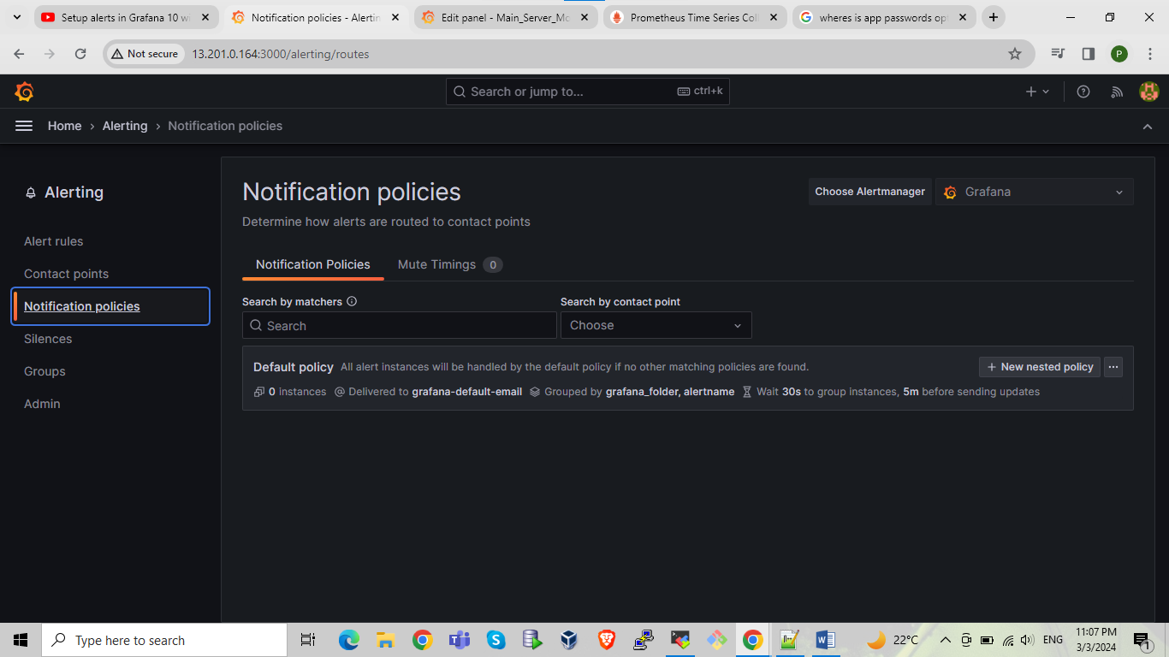

Add notification policy give label name and value as per your requirement here we are giving Label as Team and value as Admin then click save or create

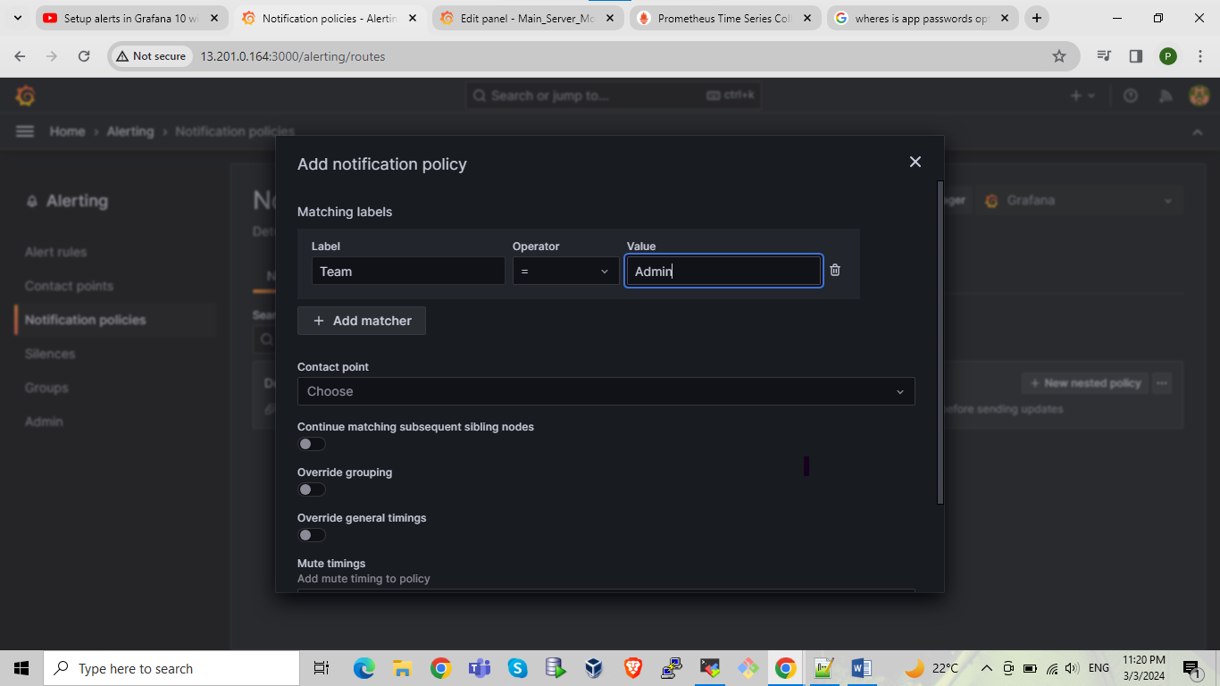

Then go into alert rules select created cpu utilization rule and edit it

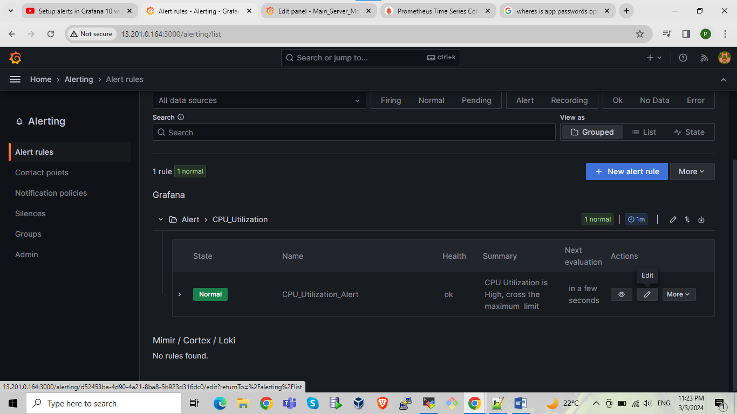

Scroll down and go into add annotations and select link dashboard and panel

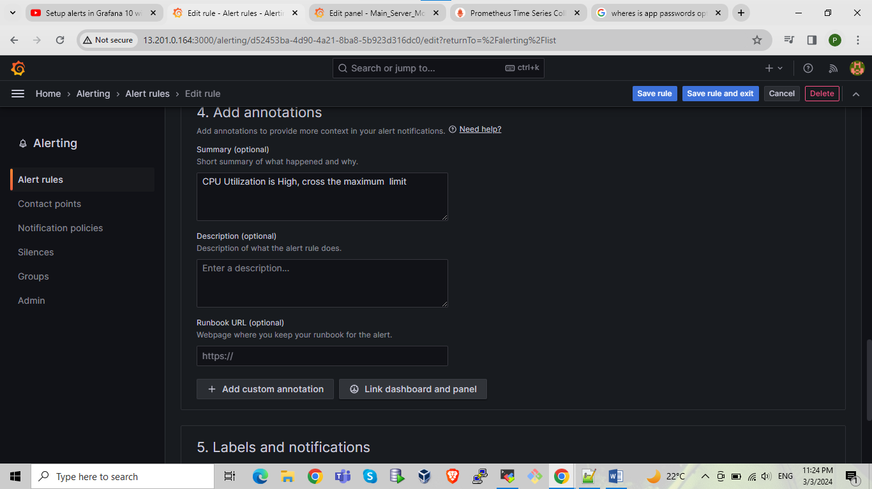

Select dashboard and panel name and confirm

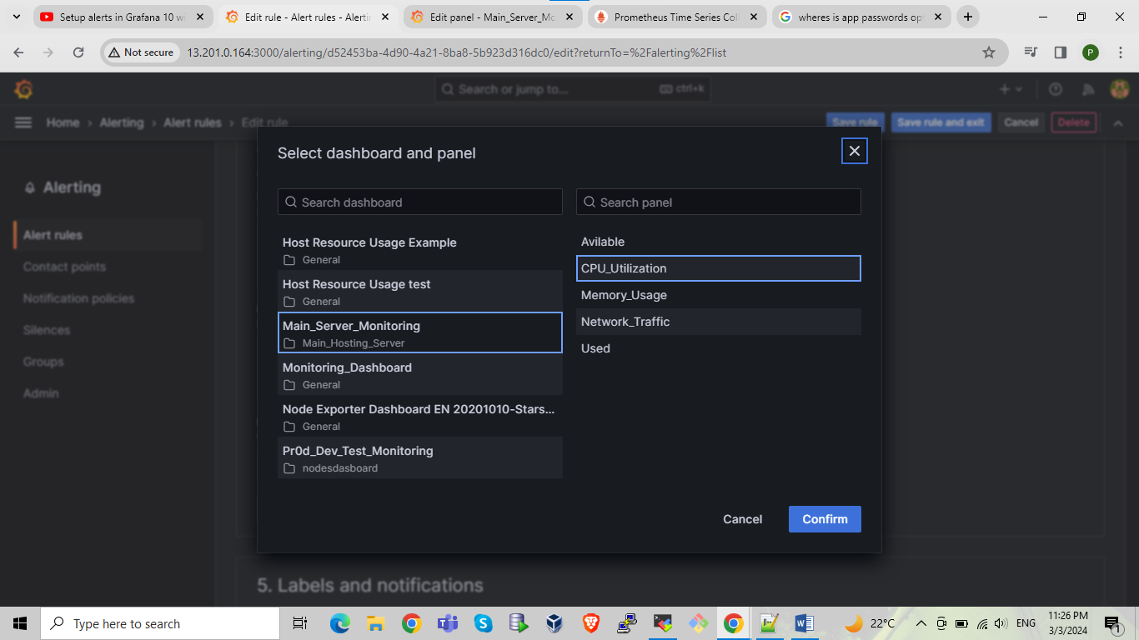

Click on save rule and exit

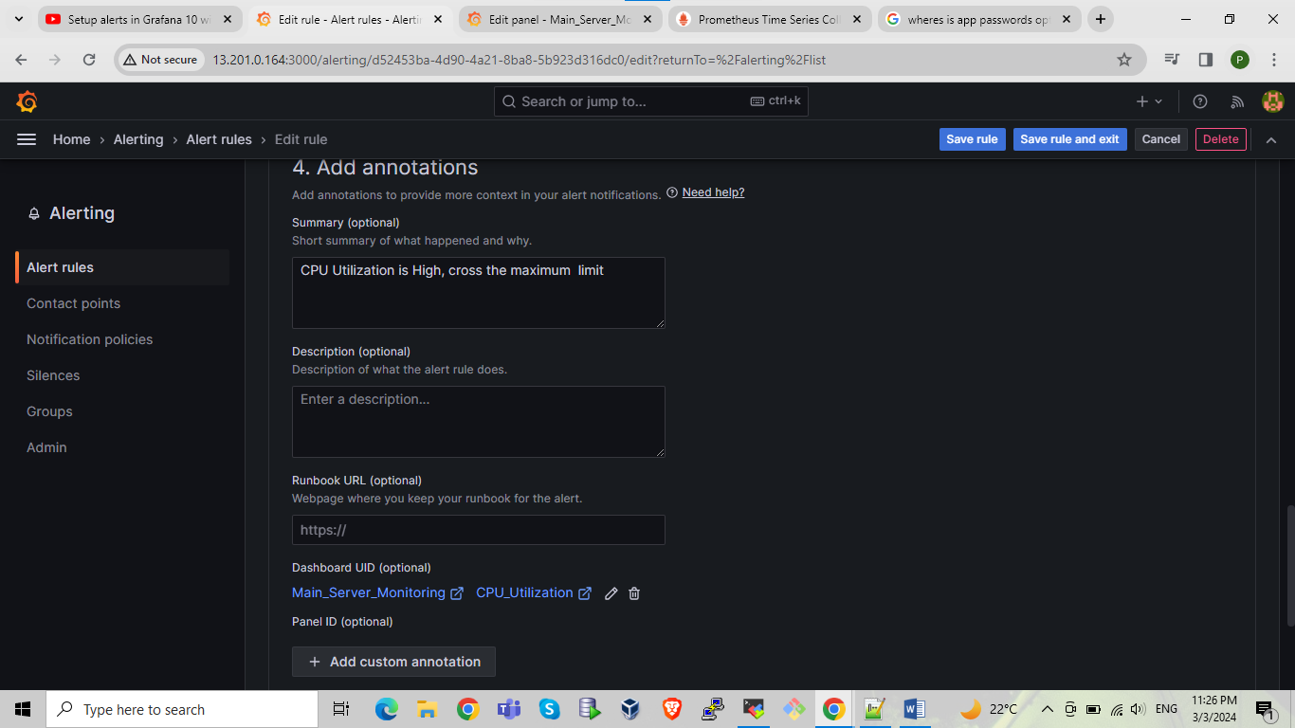

Here we can see that o panel CPU utilization alert rule is apply after that save dashboard again

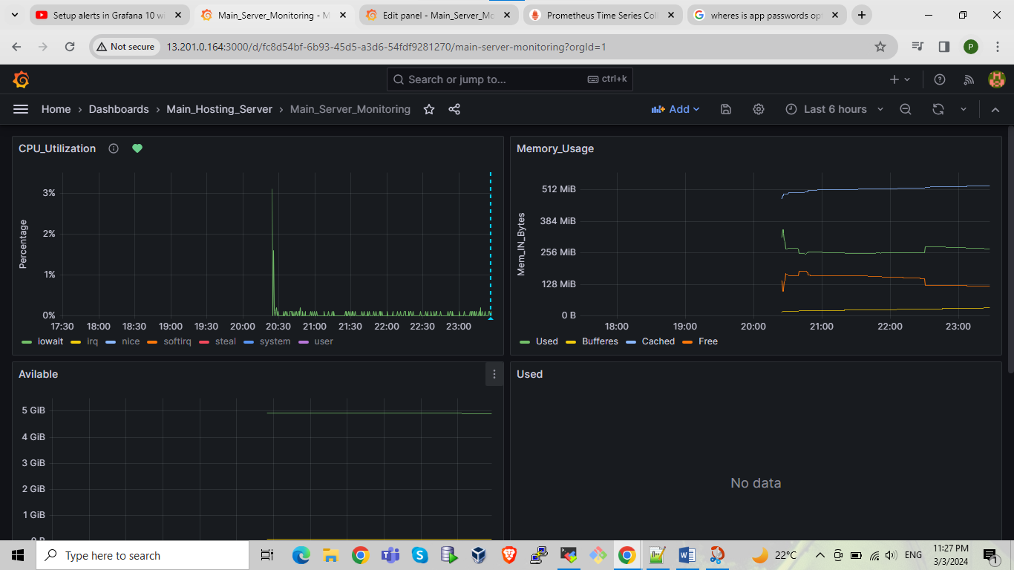

In alert set evaluation from 1m to 10 sec because it will fire alert immediately for our testing weather its working or not.

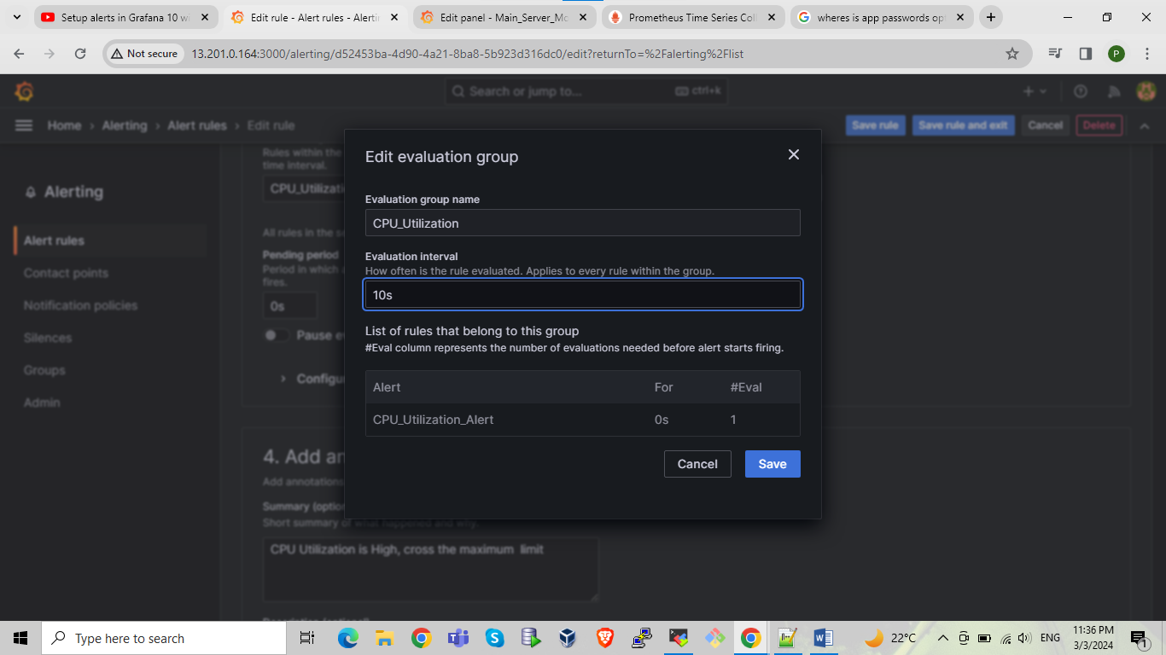

By using stress command we are increasing stress on CPU for checking alert working or not.

Command:-

stress -c 8 -t 160

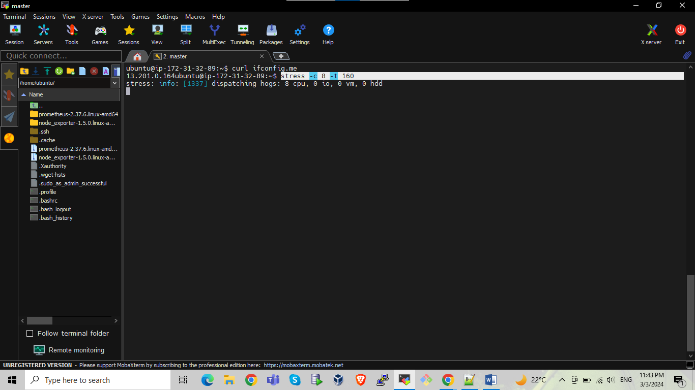

In below panel we can see alert sign showing in red color means cpu max utilization is crossed and alert is generated

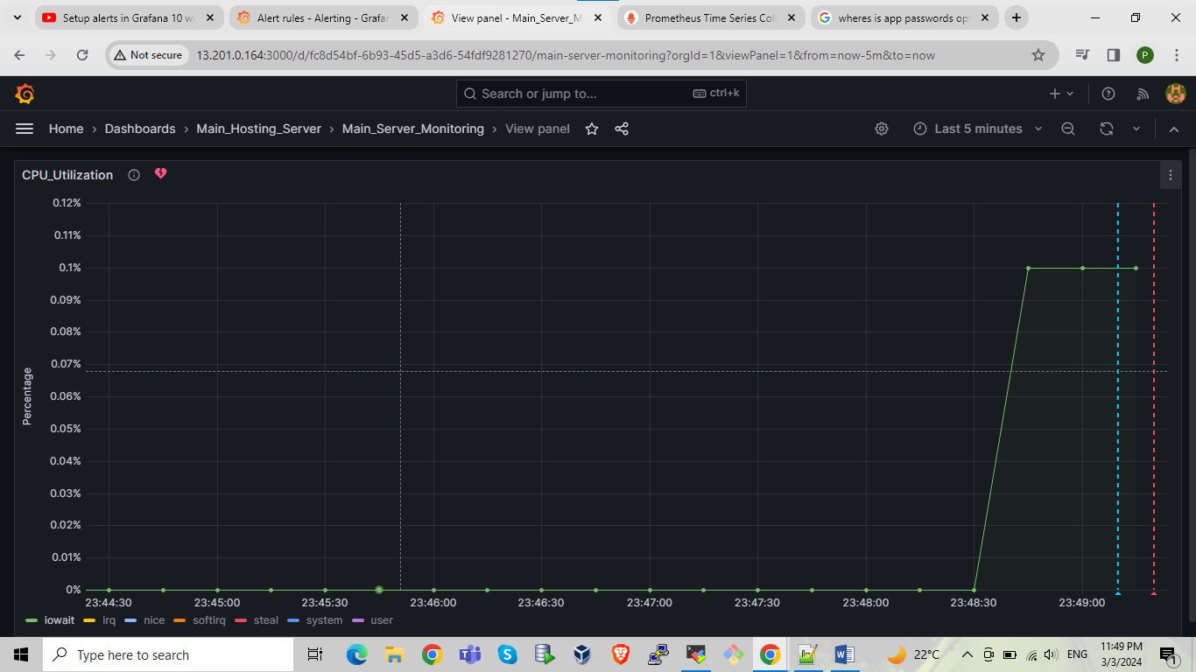

In alert section select cpu utilization alert and click on show state history we are checking alert here also it will showing the alert history

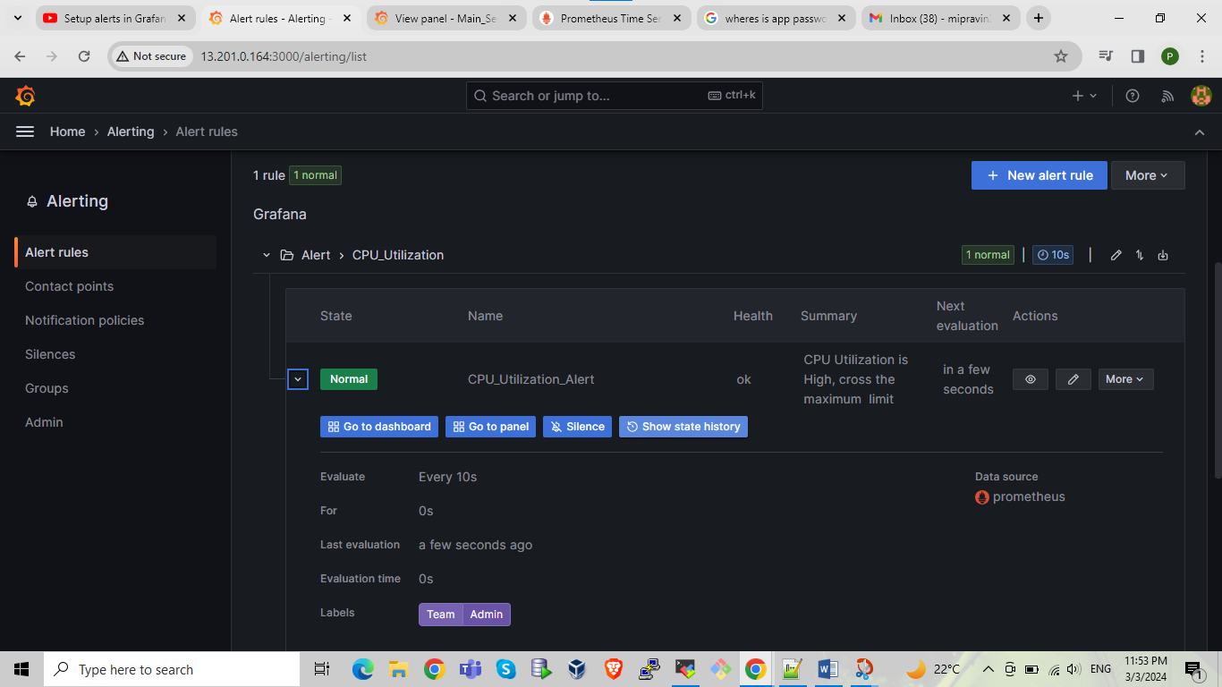

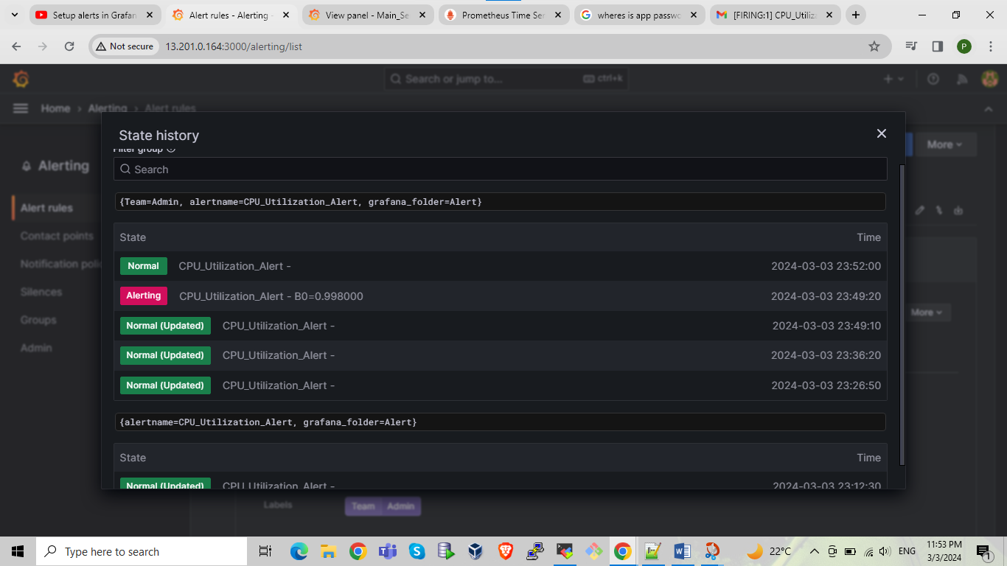

After generating alert also sending it to gmail which has been store in contact points

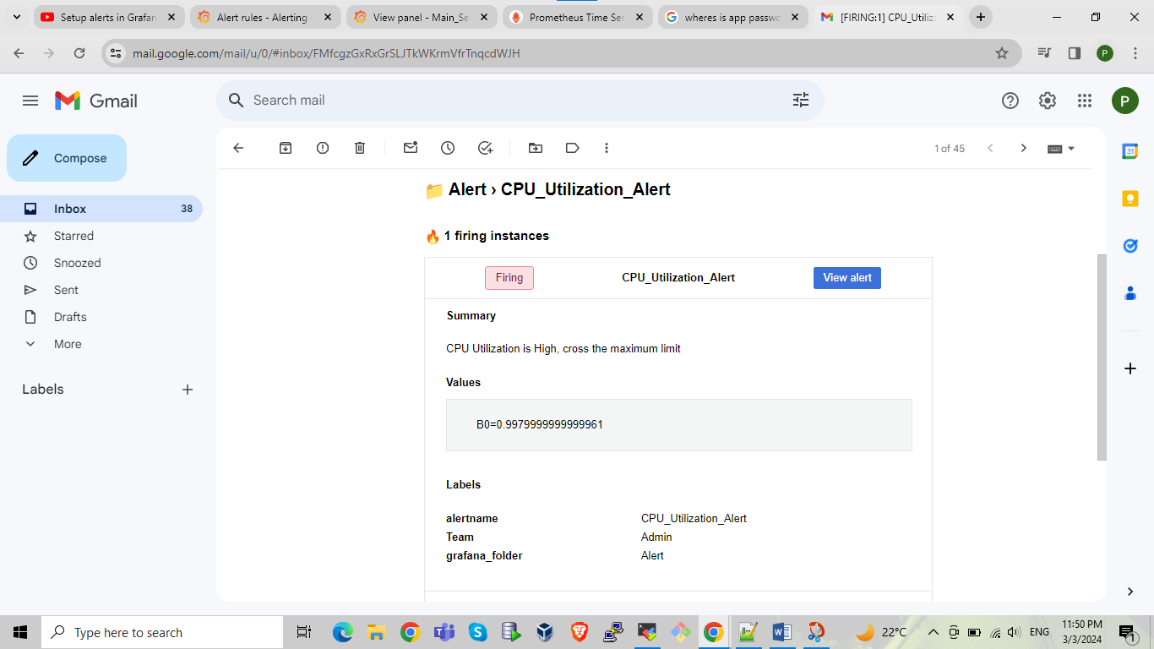

After resolve alert again send resolution mail to given mail in contact point

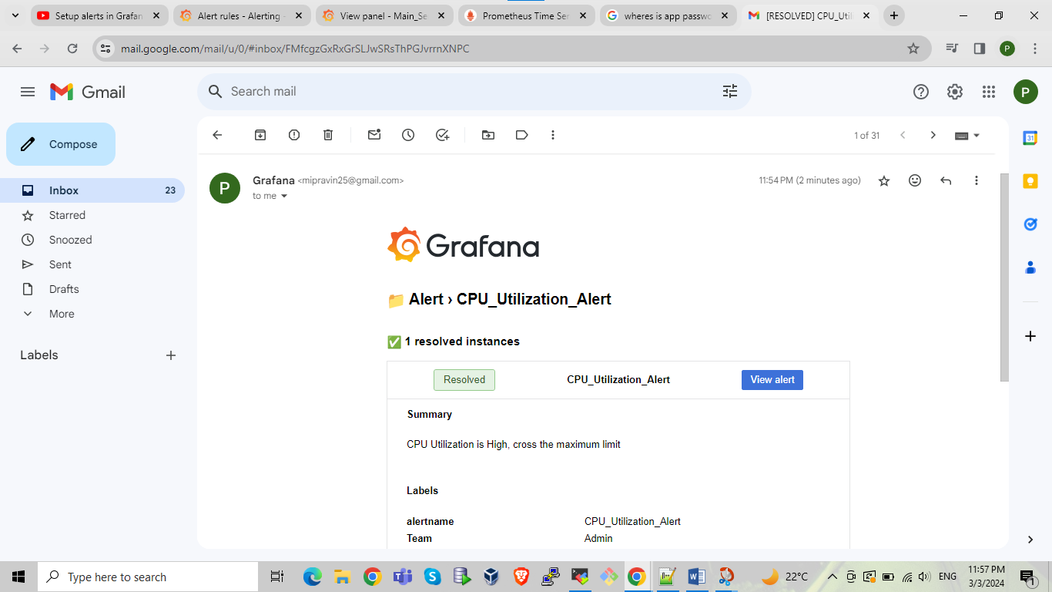

-------------------------for up and down status of server-------------------------

In grafana das board creation put below query in query area just change your ip put either public or private ip

up {instance="172.31.34.251:9100",job="remote_collector"}

After that in below of the query tab we can see the otption click on it and se;ect custome instead of legend and put the next value {{instance}}

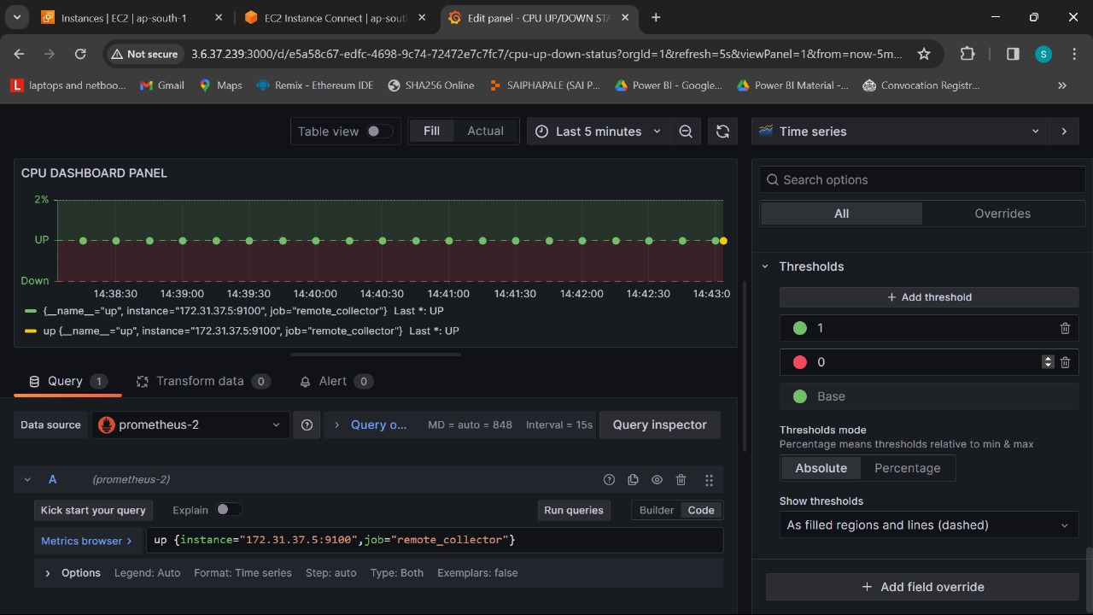

After that do the below all setting

Set unit search as showing in highlighted area

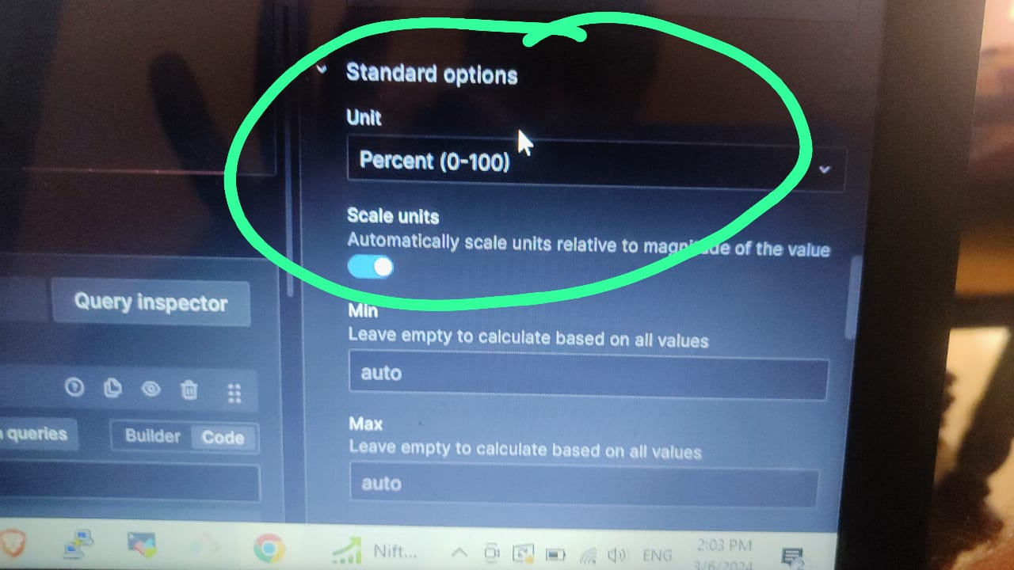

Add threshold right side of panel in bottom

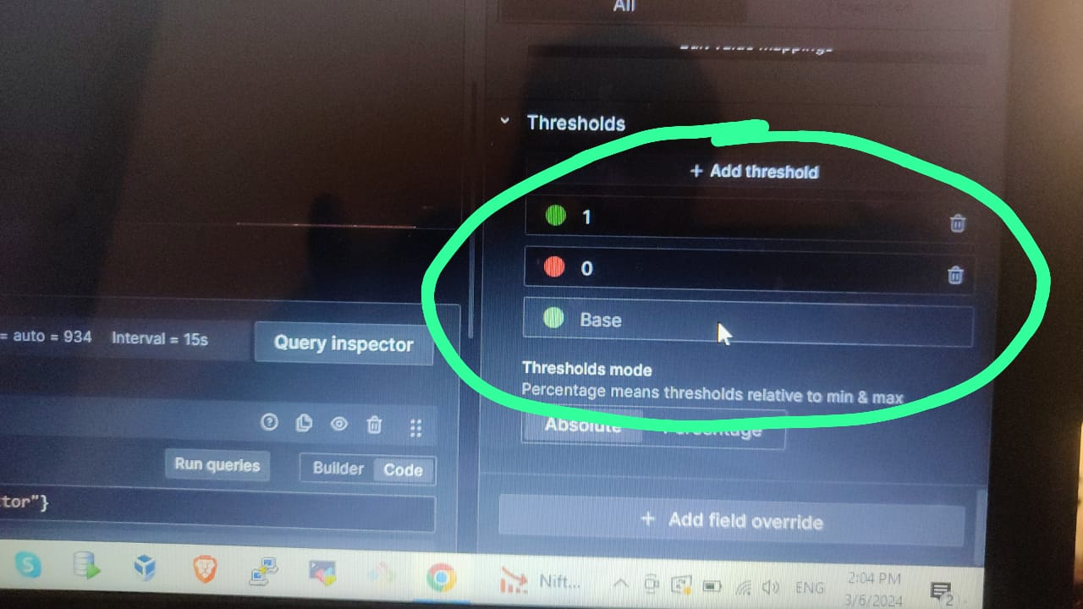

Above threshold tab we can see mapping value just map the value like below

1 for up

And

0 for down and save it

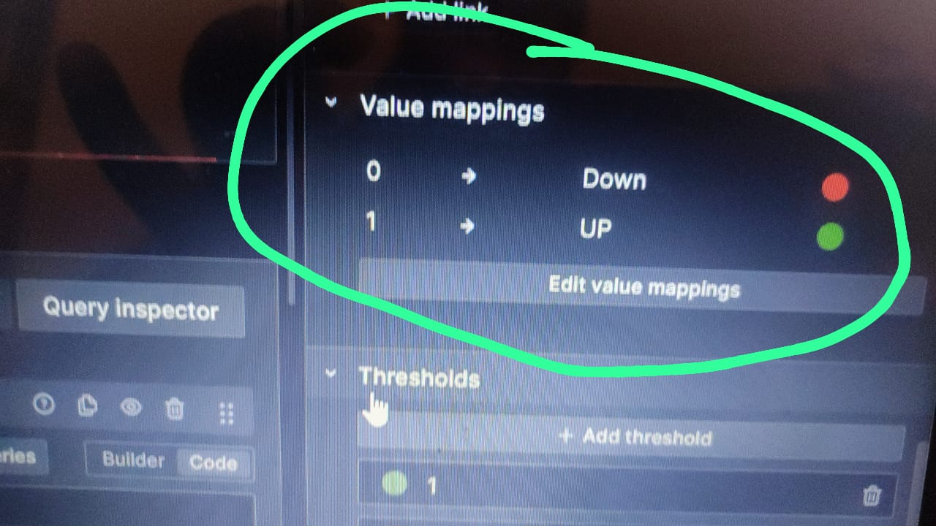

For setting up alert go into alert section set value to below 1 and put alert message do all configuration as per showing in same document for in above sections